Beginning Algebra Made Useful

Chapter 2

Charlene E. Beckmann, Ph.D.
Grand Valley State University
2020

Table of Contents
Chapter 2 Proportional Reasoning and Linear Functions 45
Activity: Function Versus Equation 45
2.1 Representations: Graphs, Data, and Algebra through Children’s Literature 45
Video: Talking About Math 45
Activity: The Eyes Have It 46
Activity: Graphing with Desmos 48
Activity: The Eyes Have It, Extended 48
2.1 Homework 48
2.2 Creating and Critiquing Graphs 50
Activity: Location, Location, Location 50
Activity: It’s a Matter of Scale 51
Activity: What’s Wrong with this Picture? Critiquing Graphs 56
2.2 Homework 58
2.3 Interpreting and Creating Graphs: The Hare and the Tortoise 60
Activity: Can You Walk these Graphs? 60
Activity: The Hare and the Tortoise 62
2.3 Homework 64
2.4 Graphs, Tables, and Linear Functions: Analyzing a Race 65
Activity: Trodding Tortoise 65
Activity: Hopping Hare 68
2.4 Homework 69
2.5 Proportional Reasoning Every Day 72
Activity: Recipes and Proportional Reasoning 72
Activity: Where Else Do You Use Proportional Reasoning? 75
2.5 Homework 77
2.6 Distinguishing Proportional Relationships from Other Linear Relationships 80
Activity: Giving the Tortoise a Head Start 80
Activity: Finding Equations from Tables and Interpreting Slope and y-Intercept 82
2.6 Homework 85
2.7 The Meanings of Slope and y-Intercept, Connecting Graphs and Equations 89
Activity: Linear Functions with Desmos – Slopes and y-Intercepts 89
Activity: Polygraphs: Linear with Desmos 91
2.7 Homework 91
2.8 Linear Functions: Big Ideas 100
Activity: Big Ideas – Slope and y-Intercept 100
2.8 Homework 102
2.9 Analyzing Tile Patterns 105
Pattern Talk: Tile Pattern 105
Activity: Analyzing Tile Patterns 106
2.9 Homework 108

Chapter 2
Proportional Reasoning and Linear Functions
Chapter 1 provided many opportunities for you to view mathematics through a variety of contexts in which mathematics arises and through connections among representations. In Chapter 2, you will continue to broaden your exposure to contexts and multiple representations, this time through those that can be modeled by linear functions. To be certain of your facility with linear functions, near the end of the chapter, we include a few functions that are not linear so that you consider more deeply what it means to be linear.

Activity: Function Versus Equation
Before we begin, let’s talk about the word, function. We used the word function a few times in Chapter 1 without defining it. For our purposes, function and equation are almost interchangeable. Equations are more general than functions. Here are some equations:
y = 3x + 4 2x – 3 = 3x + 4 8 = 3x + 4
y = 5 – 7x 14 – 7x = 5 – 7x 2(3x + 4) = 6x + 8
y = 4 x = 11 1 = – (–1)
Some of the equations above are also functions. Can you guess which equations are also functions? Circle them. Why do you think these are functions and the others are not?
There are several mathematical definitions of function online. Here are two of them:
- A function is a special relationship where each input has a single output.
(Math is Fun, https://www.mathsisfun.com/definitions/function.html, retrieved April 16, 2020.)
- A technical definition of a function is: a relation from a set of inputs to a set of possible outputs where each input is related to exactly one output.
(Math Insight, http://mathinsight.org/definition/function, retrieved April 16, 2020.)
Let x be the variable representing the set of input values. Let y be the variable representing the set of output values. Use one of these definitions to determine which of the equations above are functions. Be ready to explain your choices.

2.1 Representations: Graphs, Data, and Algebra through Children’s Literature
Children’s literature is a rich source for mathematics connections. Though the stories are intended for children, the underlying mathematics is more advanced. In this lesson, we will read a story and see how it can be represented through graphs, tables, and algebra.

Video: Talking About Math
In How to Learn Math for Students, Lesson 4, watch Video 4: Talking About Math. How can you benefit by actively working in groups both in and outside of class? Think about how well you and your group members currently interact. What ideas do you have about how to help your group work together more productively? Share your ideas with your group.

Activity: The Eyes Have It
Because variables are so important in our work with algebra, it is helpful to further develop our facility with their use. In The Eyes Have It, you will study the relationship between the numbers of monsters and the corresponding numbers of eyes (each monster has only two eyes) through tables, graphs, English sentences, and algebraic equations.
The Eyes Have It
Read Horns to Toes and In Between by Sandra Boynton. (You can find an amusing version of the book on YouTube at: https://www.youtube.com/watch?v=5J2BwEu1ueY.)
How many eyes do 3 monsters have? 4 monsters? 7 monsters? All the monsters in the book? Any number of monsters (with 2 eyes each)?
1. Record the number of eyes based on the number of people in the table.
Number of Monsters, M | 1 | 2 | 3 | 4 | 5 | 6 | M
Total Number of Eyes, E |  |  |  |  |  |  | E =
2. Graph the data in the table. Label the horizontal axis, Number of Monsters, and the vertical axis, Total Number of Eyes.
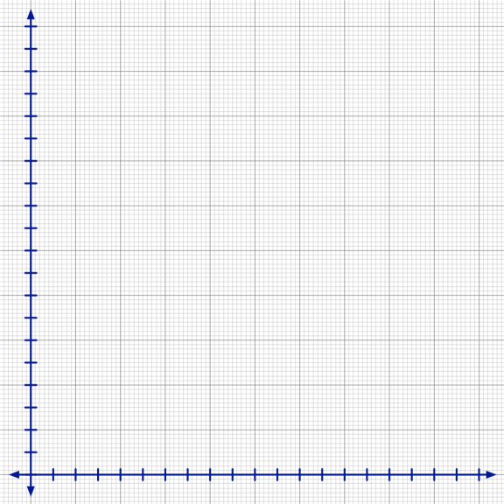
a. Starting at 0 where the two axes meet, number the tick marks on the horizontal axis increasing by 1 each time for each dark vertical line (every other tick mark).
b. Choose a reasonable scale for the vertical axis. Explain why the scale is reasonable.
c. Describe the shape of the graph.
d. Why do you think the graph has the shape it does?
3. Describe the relationship between the number of monsters and the total number of eyes the monsters have. Here is one way to phase into the use of variables:
The number of Eyes is two times the number of Monsters.
Number of Eyes = 2 x number of Monsters
E = 2 x M
E = 2M
4. Choose a body part that humans have more than 2 of. Repeat problems 1, 2, and 3 for the body part you choose. You are welcome to look up numbers on the Internet if you don’t know them.
5. Graph number of people versus total number of the chosen body part on the axes above. What do you notice?

Activity: Graphing with Desmos
Read the student page, Graphing with Desmos. Open Desmos on a computer, a smart phone, or an electronic tablet. Use the directions to plot the data from The Eyes Have It. What questions do you have? Share your graph with your group.

Activity: The Eyes Have It, Extended
What household items do Americans likely have in quantity? Find statistics about the average number of something each household owns. Repeat the activity in the Eyes Have It, problems 1 through 3, for the item you are interested in. Create a graph with Desmos to represent the data. Share your work on this problem with your group.
- How did you decide what scale to use?
- How did you find the equation to plot?
- What questions do you have?

2.1 Homework
1. Go back to the first section of Lesson 1.1, How to Learn Math for Students. Complete problem 10 on page 6. You will hand in your written reflections for problem 10 in class.
2. Revisit the student page, The Eyes Have It. Using the data in problem 4 for the Human Body Parts your group chose, create a table listing the number of body parts for 2, 4, 6, 8, and 10 people. Plot the data with Desmos. Choose appropriate scales for both x and y if the scales chosen by Desmos do not show all of the data. Find an equation to fit the data. Print out the graph and data or be prepared to share them electronically.
3. If plotting points on a coordinate grid is unfamiliar to you, or you need to dust off the skill, return to problem 2.
x | y
4 | –3
–2 | 5
0 | –1
–5 | –4
a. Compare the graph with the data table. Which number is plotted along the horizontal axis? Which number is plotted along the vertical axis?
b. Create a new table on Desmos using the values at right. Answer problem 3a again.
c. Predict the location of several more points. Enter the points into the table in problem 3b to see if you are correct.
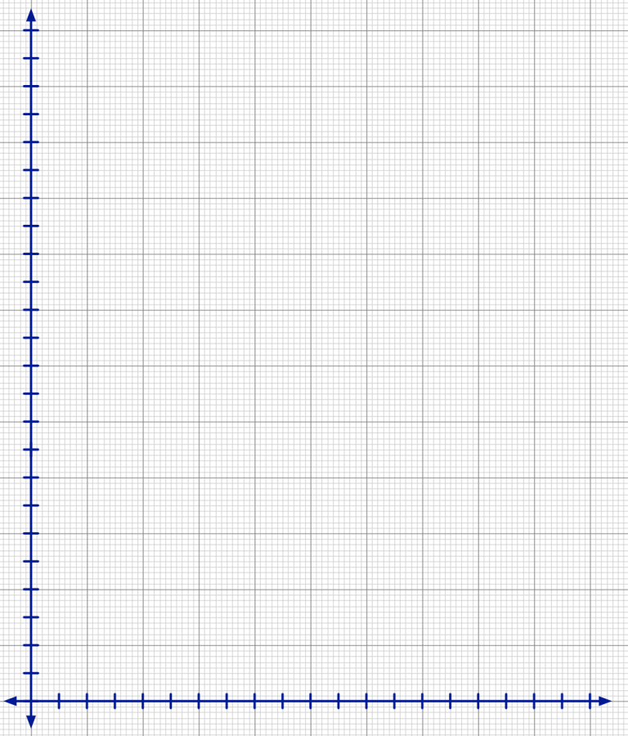
4. Movie tickets cost $8.50 each.
a. Complete the table to show the cost of the numbers of movie tickets listed if each ticket costs $8.50.
Number of tickets | Cost of tickets
0
1 | 8.50
2
3
4
10
15
n

b. Plot the data on the graph at right. Label accurate scales for both x and y so that you use most of the graph. Write titles on each axis.
c. Describe the relationship between the number of tickets purchased and the cost of that number of tickets.
d. Write the relationship in problem 4c as an equation.
5. Gasoline prices sometimes vary greatly in a day. On January 28, 2015, gasoline prices in the Muskegon, MI area ranged from $1.879 to $2.199 per gallon.
a. Complete the table to find how much you would pay for the numbers of gallons of gas listed for each gasoline price. Round prices to the nearest penny (hundredth of a dollar).
Number of Gallons of Gas Purchased, g | Price of Gas, P
Number of Gallons of Gas Purchased, g | $1.879 per gallon | $2.199 per gallon
1
2
3
4
5
10
15
g

b. Accurately plot the data. Label scales and titles for each axis.
c. Write equations in the last row of the table that fit the data. Tell how you know your equations are correct.
d. How many gallons of gasoline can you purchase for $10? Show your work for one of the gasoline prices, accurate to 2 decimal places.

2.2 Creating and Critiquing Graphs
You have seen that graphs can be helpful in representing data. In Lesson 2.2, you will specifically explore the importance of scale when graphing equations.

Activity: Location, Location, Location
Through this activity your group will create a graph to convey information about the number of people in a location over time. You will also interpret a graph prepared by another group and try to determine a location that fits the graph. To prepare, think about a place you go with some regularity. How many people are in that place at various times during the day?
To maximize the interest level, each group must choose very different types of locations. It helps if the numbers of people who go to the place each day are large. Secrecy of choice is critical! Make sure other groups cannot overhear your group’s discussions!
Complete the following with your group:
1. Choose a location and a day of the week to analyze. Get your teacher’s approval before continuing (to assure that your group chose a unique location).
2. Estimate how many people are likely to be in the location at the beginning of each hour of the day, starting at 6 AM and ending at 5 AM the following day. Record the data.
3. Create a graph to accurately represent the data.
- Use the horizontal axis to indicate the hour of the day.
- Use the vertical axis to indicate the estimated number of people in the location at the beginning of each hour.
- Do not include any information on your graph that identifies the location your team is analyzing.
When you have accomplished the above, your teacher will share your graph with another group and provide another group’s graph for your group to analyze.
4. For the new graph:
a. Decide what location the graph likely represents.
b. Explain to each other why the graph could represent the location you think it does.
c. Write questions you have about the graph.
5. What features of graphs help you interpret them? What makes these features helpful?
6. Share the graph with the class when asked to do so. Ask questions to help you and others analyze the graph.
Location, Location, Location is adapted from Annenberg Learner, Teaching Math: A Video Library, 5–8, The Location, http://www.learner.org/channel/schedule/printmat.html?printmat_id=123, retrieved April 16, 2019.

Activity: It’s a Matter of Scale
How important are the scales chosen for both the horizontal and vertical axes to the appearance of a graph or a group of graphs? Think about this question as you work together on the student page, It’s a Matter of Scale.
Among groups, compare graphs for problems 3 and 4a. What do you notice? Think about these questions:
- Are all of the graphs the same shape?
- Why did all of the graphs look the same in problem 3?
- Why do the graphs look different in problem 4a?
Discuss the importance of scale.
Think about the activity, Location, Location, Location. How important was scale in helping you determine the location of each place? Does the x-scale matter? Does the y-scale matter?

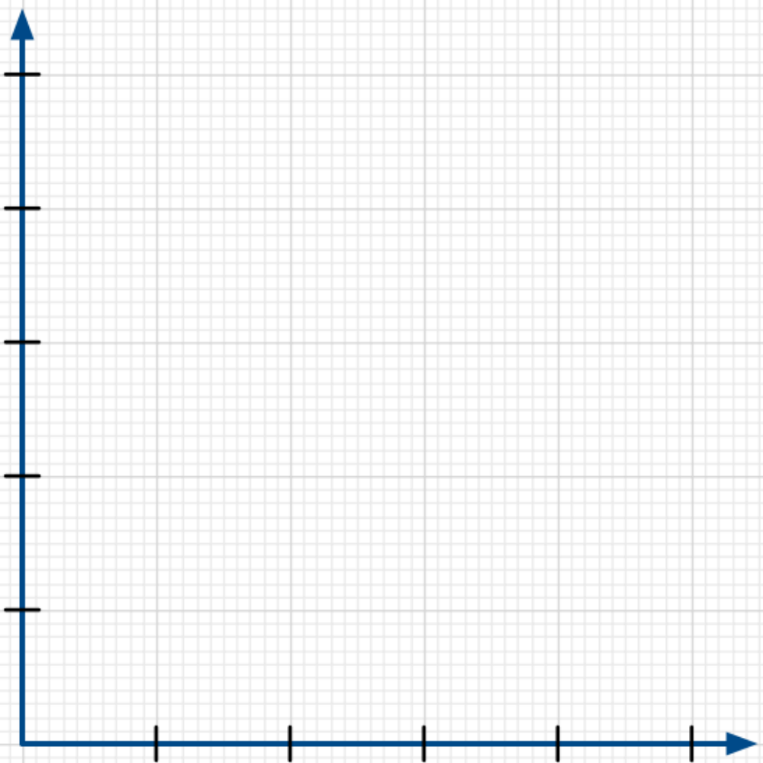
It’s a Matter of Scale
Directions: Each group member receives a card with an equation on it and both x- and
y-scales to use to graph the equation.
1. Starting with zero at the origin, the point where the axes intersect, each tick mark increases by the amount of the scale provided. Label both the x- and y-axes showing the scale on the card.

2. Create a table that fits the equation and x-scale you were given. Plot the points in the table on the coordinate grid. Graph the equation by connecting the points you found. Write the equation of the line on the graph you drew.
3. a. Compare the graphs drawn by members of your group and class. What do you notice?
b. Look carefully at the equations plotted and the scales used. Should the graphs appear as they do? Why or why not?
c. Explain why the graphs appear as they do.

4. Work with other members of your group.
a. Graph the equations each person was provided on the same graph using the largest x- and y-scales provided in the set of cards.
b. What do you notice?
c. Discuss any differences in the appearances of the graphs compared to the graphs plotted in problem 2.
d. Why do the graphs in problem 2 look different from the graphs in problem 4a?

5. Write about the importance of scale in graphing.

It’s a Matter of Scale Card Set
Directions: Print or copy pages 54 and 55, on separate sheets of paper. Cut the cards apart. Each group member receives one card with all four cards in a row assigned to the same group.

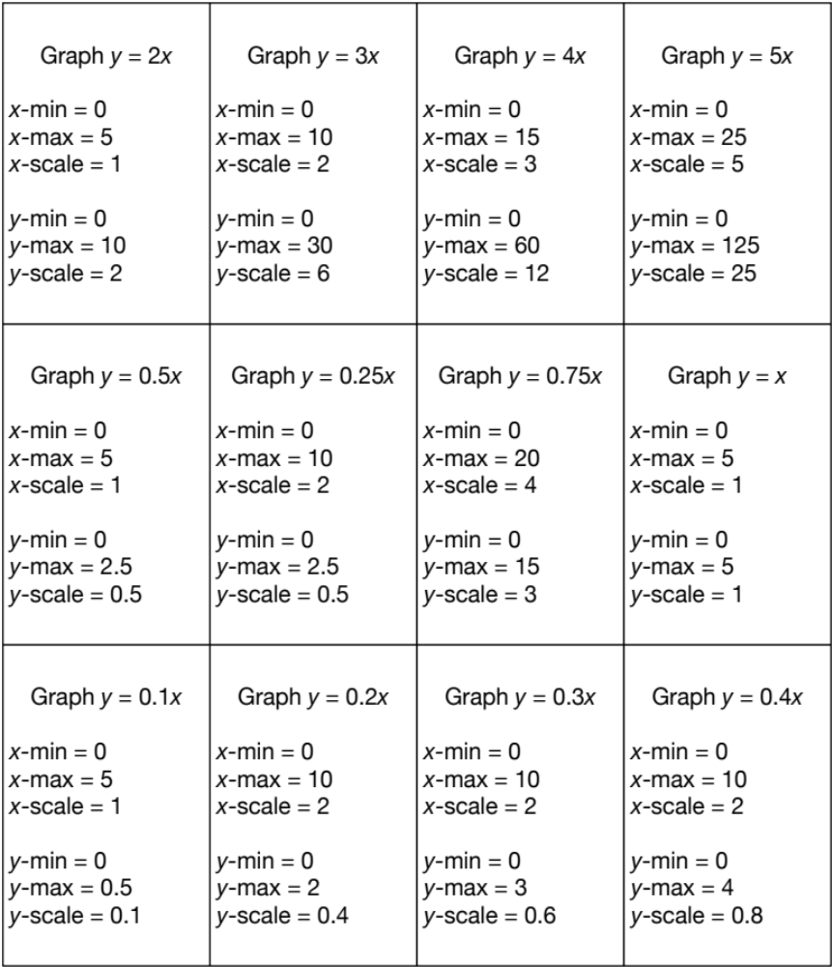

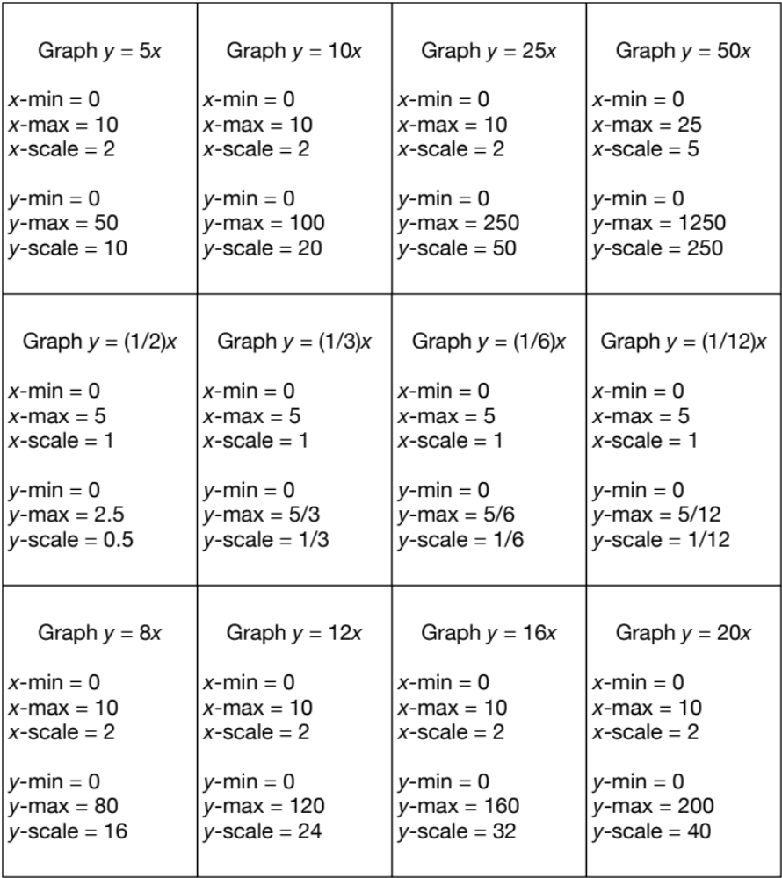

Activity: What’s Wrong with this Picture? Critiquing Graphs
News articles and ads are sometimes accompanied by graphs. Sometimes these graphs are deceiving. Complete the student page, What’s Wrong with this Picture?, in light of what you have learned about scale. In each graph check to see if the x- and y-scales are correct. Are the distances between each of the x-values to scale? Are the distances between each of the
y-values to scale? How can you tell?
Plot each graph using an electronic tool. Set the x and y scales to be the same as those used in each graph. Compare the appearance of the graph you created with the designed graph.
Critiquing Graphs: What’s Wrong with this Picture?
1. Study the graphs. Some are accurate, some are not. For each graph:
a. Determine if it is drawn accurately. Recreate the graph electronically to help you decide.
b. Which graphs are good representations of the data?
c. Which graphs still need work to make them more accurate? What parts of these graphs need work? Describe any changes needed to help the viewer accurately interpret the information provided.

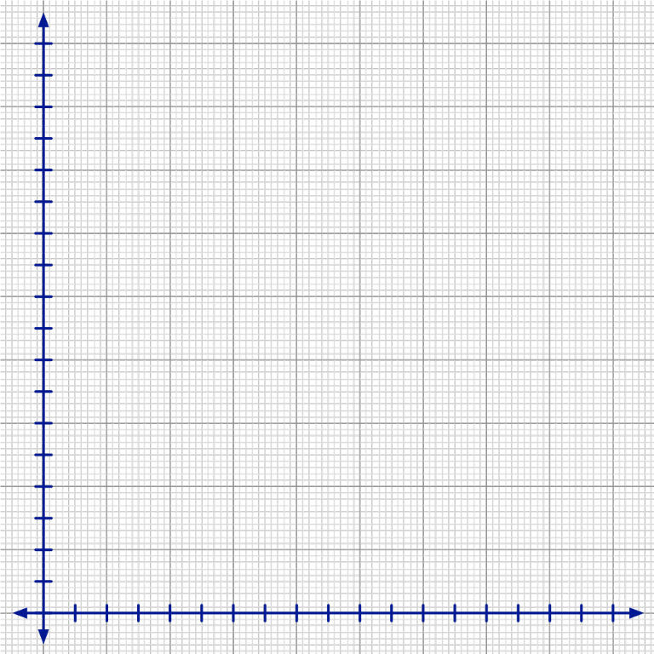
60th District Court
Traffic Fines and Costs Schedule
Speeding on Interstate | FINE
71-75 mph | 115.00
76-80 mph | 125.00
81-85 mph | 135.00
86-95 mph | 145.00
96 mph or more | 155.00

2. Consider the table above.
a. The independent variable is the variable that changes independent of any other variable. Either you must manipulate this variable yourself, or it changes on its own; it does not rely on the other variable. In the table, what is the independent variable? Why do you think so?

b. The dependent variable is the variable that depends on another variable. What is the dependent variable in the table? Why do you think so?

c. Use the graph provided to display the data in the table. In mathematics, the horizontal axis always represents the independent variable. The vertical axis always represents the dependent variable.
3. What are important features of an accurate, informative graph?

4. Read a data analytics co-founder’s point of view of how graphs can distort the facts: http://www.huffingtonpost.com/raviparikh/lie-with-data-visualization_b_5169715.html, retrieved April 21, 2020.
a. The author indicates three of the most common ways graphs can be designed to cause data to be misleading. Are any of these ways used to create misleading graphs in problem 1?
b. Find or create a graph (if you create the graph use real data) that misleads the public. Explain what is misleading about the graph.

Data sources for graphs, retrieved April 20, 2020:
- Amount Needed to Equal the Buying Power of $15,000 in 1953: https://www.in2013dollars.com/New-cars/price-inflation.
- Consumption of Sugar Drinks by Age: U.S. Department of Health and Human Services, Centers for Disease Control and Prevention, National Center for Health Statistics, NCHS Data Brief No. 71, August 2011.
- Number of McDonald’s Restaurants in the U.S.A.: https://www.statista.com/statistics/256040/mcdonalds-restaurants-in-north-america/.
- Millions of Records Exposed in U.S.A. Data Breaches: https://www.statista.com/statistics/273550/data-breaches-recorded-in-the-united-states-by-number-of-breaches-and-records-exposed/.

Through the student page, What’s Wrong with this Picture? Critiquing Graphs, you had the opportunity to determine important features of accurate, informative graphs. Your list should include:
The Origin: Both the x- and y-axes must include zero. The intersection of the two axes is called the origin. It represents (0, 0), the place where both x and y are zero.
Scale: The distance between consecutive tick marks must represent the same distance as the distance between 0 and the first tick mark. The x-scale can be different from the
y-scale. Use as much of the graph as possible while still using a scale that is easy to interpret.
Plotting Points: Once the scale is chosen, the data points must be plotted accurately. Each point has 2 coordinates, (x, y), where x represents a value of the independent variable and y represents the corresponding value of the dependent variable. If the scales for x and y are chosen so that they are easy to interpret, it is likely the points will be relatively easy to locate and plot.
Labels: Label both axes with the quantities they represent. The x-axis (horizontal) represents the independent variable. The y-axis (vertical) represents the dependent variable.
Title: In formal documents, a title is necessary. For our purposes, a title on the graph is required when the graph represents data given in context.

2.2 Homework
1. Optional. Go back to the first section of Lesson 1.1, How to Learn Math for Students. Complete problem 11 on page 6. Completing the course helps you develop and build a growth mindset in mathematics. Keep the ideas you have learned from How to Learn Math for Students in mind as you complete Beginning Algebra Made Useful and any future courses you take in mathematics. Hand in your earned certificate of completion in class to earn privileges as designated by your professor for completing the course.
Number of minutes | Number of steps taken
1 | 100
10
20
30
40
2. One mile equals 2000 average steps while walking. If you walk at a rate of 3 miles per hour, you will average 100 steps per minute. (Resource: https://www.verywellfit.com/pedometer-step-equivalents-for-exercises-and-activities-3435742, retrieved April 21, 2020.)
a. Complete the table.
b. Plot the number of minutes versus the number of steps taken. Indicate the scales and titles for each axis.

Hours worked | Amount earned
1
10
20
30
40
3. As of January 1, 2020, the minimum wage for non-tipped employees in Michigan is $9.65 per hour. How much will you earn if you work h hours?
(Resource: https://www.paycor.com/resource-center/minimum-wage-by-state, retrieved April 21, 2020).
a. Complete the table.
b. Plot the number of hours worked versus the amount earned. Indicate the scales and titles for each axis.
c. Choose another state from the website. Complete a table and graph the data for the state you chose.
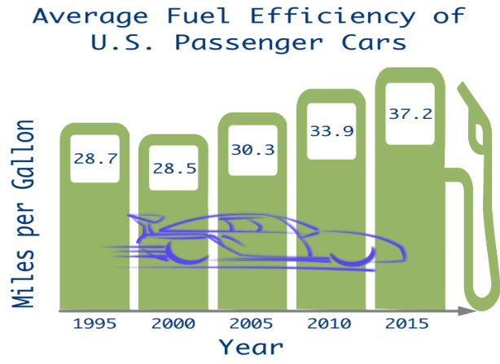
4. The graph at right indicates the average fuel efficiency in miles per gallon for a new car in the year shown.
a. Complete the table for the data in the graph at right.

Year | Adjusted year, x | Fuel efficiency  in mpg
1995 | 0
2000 | 5
2005
2010
2015

(Resource: https://www.bts.gov/content/average-fuel-efficiency-us-passenger-cars-and-light-trucks, retrieved 4/21/20.)
b. Plot the data, Adjusted Year versus Average Fuel Efficiency.
c. Is the graph accurate for the set of data you listed in problem 4a? Why or why not? Discuss both x and y-scales and other pertinent aspects of accurate graphs.
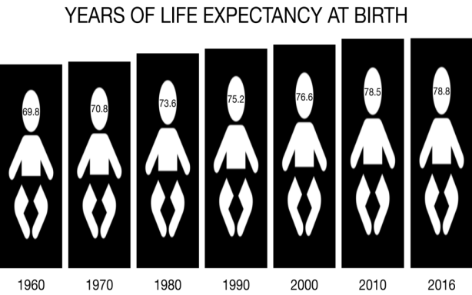
5. Study the figure at right. Life expectancy at birth indicates the number of years a newborn would live if prevailing patterns of mortality at the time of birth stay the same throughout life.
Resource: https://data.worldbank.org/indicator/SP.DYN.LE00.IN, retrieved April 22, 2020.
a. Create a table for the data in the figure. Year is the independent variable.
b. Adjust the values for the independent variable so 1960 is year 0.
c. Plot the data, adjusted year vs. Years of life expectancy at birth.
d. Is the figure accurate for the set of data you listed in problem 5a? Why or why not?
6. Find more graphs to analyze in print or online news sources. Find at least one graph that is complete and accurate. Find at least one graph that is misleading. In both cases, state briefly how you know the graph is accurate or how you know the graph is misleading.

2.3 Interpreting and Creating Graphs: The Hare and the Tortoise

Activity: Can You Walk these Graphs?
Use a Calculator-Based Ranger (CBR) connected to a graphing calculator to walk the graphs shown on the student page. For each graph, decide how you will move before you walk. If the graph created by the CBR does not match the graph on the student page, think more carefully about what movement the graph represents. Revise your walk to recreate the graph. What does the x-axis represent in terms of your movement? What does the y-axis represent in terms of your movement? How do you know?
Can You Walk these Graphs?
1. Use a graphing calculator and a CBR walk to create these graphs. How do you need to move to create each graph?
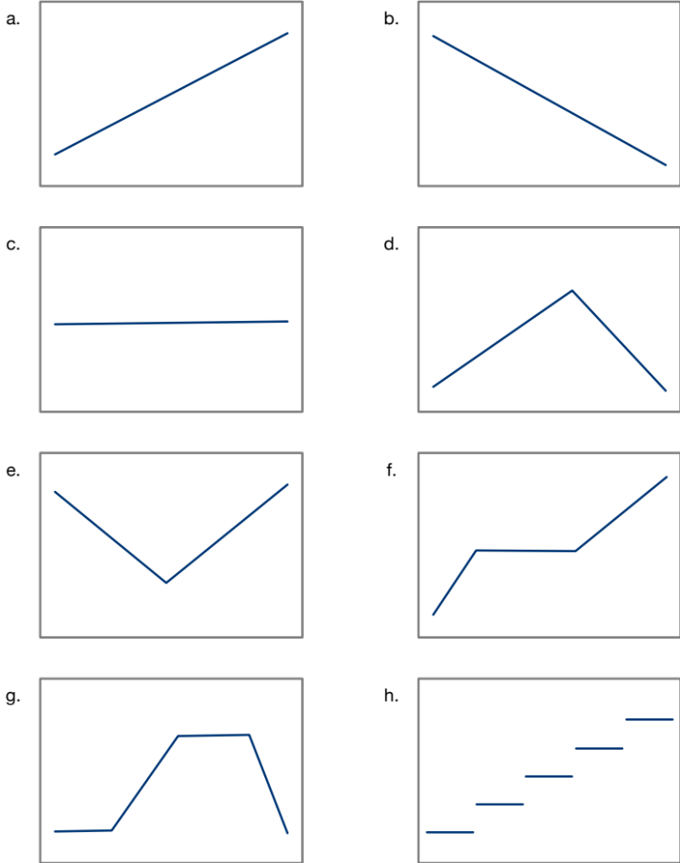
2. a. What does the x-axis represent? Why do you think so?

b. What does the y-axis represent? Why do you think so?

3. Challenge each other by creating other graphs to match. Also try to walk some of the graphs in the Distance Match application in the Easy Data program for the CBR.

Activity: The Hare and the Tortoise
The Hare and the Tortoise extends the work you began in Can You Walk These Graphs? Now consider a race between two unlikely contestants. You will draw a graph to represent each contestant’s movement and explain how you know each graph is correct. You will also analyze and interpret additional graphs of the Hare’s performance in subsequent races. Finally, you will create your own graph and story to accompany it.
Taken together, these activities, Can You Walk These Graphs? and The Hare and the Tortoise, help you bring your extensive familiarity with traveling from one place to another to bear on your learning first about graphs and then about linear functions.
The Hare and the Tortoise
Aesop (translated by George Fyler Townsend)
A hare one day ridiculed the short feet and slow pace of the tortoise. The latter, laughing, said, “Though you be swift as the wind, I will beat you in a race.” The hare, deeming her assertion to be simply impossible, assented to the proposal; and they agreed that the fox should choose the course, and fix the goal. On the day appointed for the race they started together. The tortoise never for a moment stopped, but went on with a slow but steady pace straight to the end of the course. The hare, trusting to his native swiftness, cared little about the race, and lying down by the wayside, fell fast asleep. At last waking up, and moving as fast as he could, he saw the tortoise had reached the goal, and was comfortably dozing after her fatigue.
(Source: http://www.pitt.edu/~dash/type0275.html#townsend. Retrieved July 27, 2016.)
1. a. On the coordinate grid, draw a graph to illustrate the tortoise’s distance from the starting line over the time it took her to complete the race.
b. On the same grid, draw a graph to illustrate the hare’s distance from the starting line over the time it took him to complete the race.
c. Explain how you know each graph fits the story.
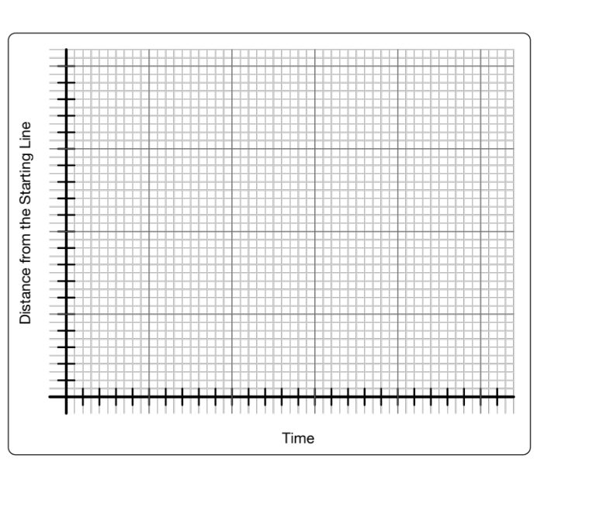

2. Study Graphs A, B, C, and D. Each graph shows the hare’s movement in subsequent races.
a. Where on the axes would it make sense to mark the starting line set by the fox?
b. Where on the axes would it make sense to mark the finish line set by the fox?
c. Write a story to go with each race. Describe specifically how the hare is moving:
- Where does the hare start the race? Finish the race?
- At what time does the hare start the race? Finish the race?
- How fast is the hare moving on each time interval compared to his speed on the other time intervals?
- What direction is the hare moving?
- How do the start and finish times and locations compare from race to race?
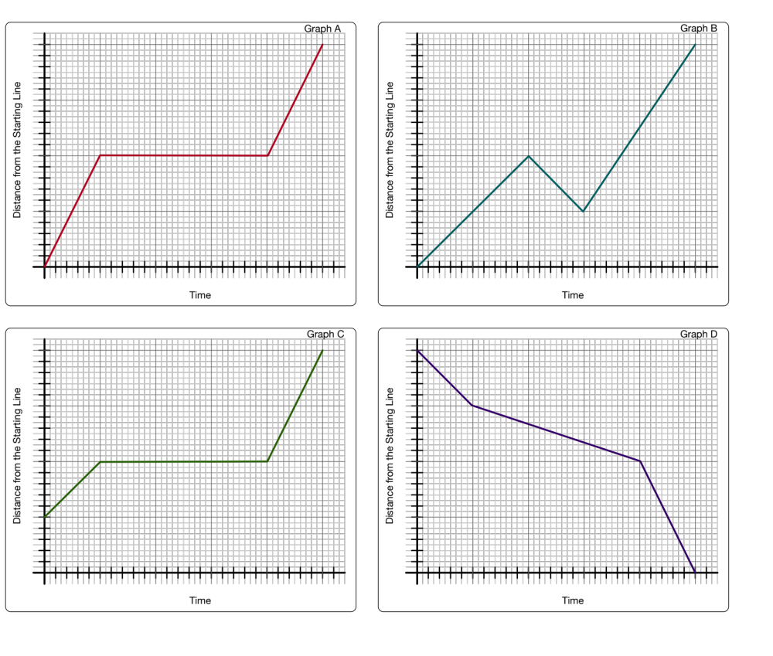

3. Write your own travel story. Draw a graph to illustrate the characters’ distance from a starting location at each time during their travels.
4. Reflections:
a. What clues do you look for in a travel story to help you create a graph to model the time and travel?

b. What clues do you look for in a graph to help you interpret the graph in terms of time and travel?

2.3 Homework
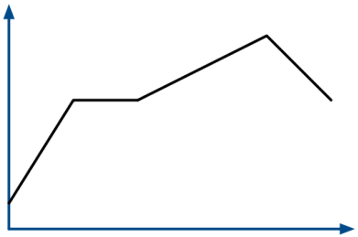
1. To get a motion detector to generate the graphs below, how would you have to walk? Describe where the motion detector is located, your relative speed over each section of the graph, how you must walk so that the corners appear, etc. Label points (a, b, c, d, etc.) on the x-axis to help the reader interpret your description of your walk over each time interval.

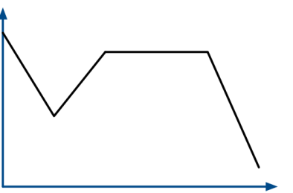

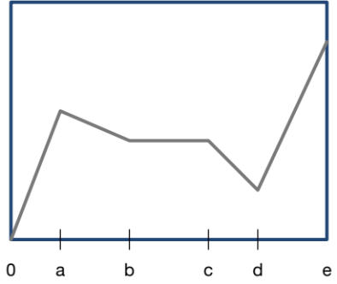
2. The hare’s travels were recorded in the graph at right. Use the labels on the horizontal axis to write a plausible story to go with the graph. Indicate the hare’s relative speed and in what direction he was moving. Let 0 on the vertical axis represent the starting line.

2.4 Graphs, Tables, and Linear Functions: Analyzing a Race

Activity: Trodding Tortoise
In Trodding Tortoise, continue to model motion with graphs and consider the race between the Hare and the Tortoise in another way. This time, from knowledge of the tortoise’s speed, create a table showing the tortoise’s distance from the Starting Line at various times during the race. Plot points and consider the appearance of the graph as it relates to the tortoise’s speed over several time intervals. Find an equation that models the data. Finally, consider the many ways that the Tortoise’s speed arises in the table, graph, and equation. In the end, define slope.
Trodding Tortoise
During the race between the tortoise and the hare, the fox recorded the speed at which both the tortoise and the hare were traveling. The fox observed that the tortoise plodded along at a rate of 20 meters per minute throughout the 1000-meter race.
1. a. Complete the table below indicating the distance traveled by the tortoise in the time elapsed.
Time elapsed in minutes, t | 0 | 1 | 2 | 3 | 4 | 5 | 6 | 7
Distance traveled in meters, D | 0
Time elapsed in minutes, t | 10 | 15 | 20 | 25 | 30 | 35 | 40 | t
Distance traveled in meters, D
b. Which variable is the independent variable? Why do you think so?

2. For each axis, choose a scale so the graph shows the tortoise’s complete race, points are easy to plot, and you use as much of the graph as possible.
a. The horizontal axis represents the independent variable. Label it using the scale you chose.
b. The vertical axis represents the dependent variable. Label it using your chosen scale.
c. Label each axis with the variable it represents.
d. Sketch a graph that represents the tortoise’s progress during the race using the data in the table.
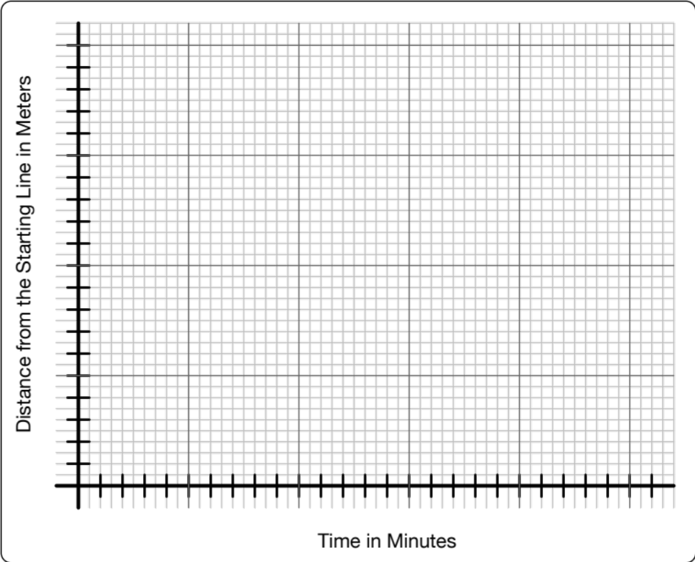
3. a. In one minute, how far did the tortoise travel? What does this number represent in terms of the tortoise’s movement during the race?

b. How can you find the distance the tortoise traveled directly from the number of minutes that have elapsed since the start of the race?

c. Let t represent the elapsed time in minutes and D represent the distance in meters traveled by the tortoise. Write an equation showing the relationship between t and D:
D =
d. Replace t in the equation in problem 3c with some of the values in the table. What values did you get for D from the equation? Did the equation values for D match those in your table? Should they match?

e. How does your answer to problem 3a relate to the equation you found in problem 3c?

4. a. Complete the table below for the tortoise’s travels for each of the time intervals indicated.
Time Interval | Amount of time elapsed | Change in distance during the time interval | The tortoise’s speed
0 to 5 minutes
5 to 10 minutes
10 to 20 minutes
b. How can you find the tortoise’s speed over each time interval? Explain. Enter the speed in the table.

c. Compare the tortoise’s speeds for the three time intervals in the table. What do you notice?

d. Should the tortoise’s speeds for each time interval be the same? Why or why not?

e. The slope of a line is the steepness of the line. What is the slope of the line that models the tortoise’s movement?

5. How long does it take the tortoise to complete the race? How do you know?

Activity: Hopping Hare
Extend what you learned through Trodding Tortoise to analyze the Hopping Hare’s motion, data, and graph and relate these to equations that model each part of his race.
Hopping Hare
1. The fox made the following observations about the hare’s movement during the race with the tortoise:
- The hare traveled at a constant rate of 250 meters per minute for the first 2 minutes.
- The hare’s nap started at exactly 2 minutes and lasted exactly 47.5 minutes.
- The hare woke suddenly and traveled at a constant rate of 500 meters per minute during the last minute of the race.
a. Complete the following table indicating the distance traveled by the hare in the elapsed time.
Time Interval | Amount of time elapsed | Change in distance during the time interval | The hare’s speed
0 to 2 minutes |  |  | 250 meters per minute
2 to 49.5 minutes
49.5 to 50.5 minutes |  |  | 500 meters per minute
b. Use the axes you used to draw the tortoise’s progress (Trodding Tortoise, problem 2) to draw an accurate graph to represent the hare’s progress during the race from the information in the table and the fox’s observations. What points will help you draw an accurate graph?

c. Draw an accurate graph for the hare’s progress during the race.

2. Write an equation relating elapsed time, t, and distance, D, traveled for the hare’s first 2 minutes of travel.
D =
3. Use the equation you found in problem 2 to answer the following questions:
a. How far did the hare travel during the first 15 seconds (0.25 minutes) of the race?

b. If the hare had continued traveling at this rate, how long would it have taken him to complete the 1000-meter race? Would the hare have won?

c. How far could the hare have traveled if he continued at this rate for the entire 50.5 minutes?

2.4 Homework
4. a. Find an equation relating the hare’s elapsed time and distance traveled for 2 minutes to 49.5 minutes. Keep in mind that he is not sitting on the starting line at the beginning of this time interval.

b. What is the slope of the equation you found in problem 4a? Why does this slope make sense?

5. a. What is the slope of the line that shows the hare’s movement during the last minute of the race?

b. Is the slope enough to determine an equation for the last minute of the race? Why or why not?

6. Desmos allows you to plot equations based on time intervals.
a. Open a Desmos worksheet. Click on the ? icon (Help) in the top right corner of the page. Click on the icon for Restrictions and learn how to use them.
b. Plot the equation for the tortoise.
c. Plot the two equations you found for the hare. For the hare’s equations, restrict x to the intervals over which the fox observed him. What do you notice about how Desmos plots the hare’s graph?
d. (Optional) You already know the slope for the last minute of the hare’s travels. Play with a third equation for the final time interval of the hare’s race to approximate the equation for this part of the hare’s race.

1. Consider your work on the student pages, Trodding Tortoise and Hopping Hare. Write about your current understanding of slope and the relationships between slope, speed, rate of change in a table of values, and the change in distance divided by the change in time. In particular, how does speed show up in the table? How does it show up in the graph? How does it show up in an equation?
2. Revisit the student page, The Eyes Have It. The relationships you investigated in The Eyes Have It are called proportional relationships. In linear proportional relationships, you get one quantity by multiplying the other by a constant. Are any of the Tortoise and Hare relationships proportional? See if you can find 2 or 3 examples.
3. There are 8 sticks of gum in a small package.
a. Create a table to show the number of sticks of gum in 0, 1, 2, 3, 4, 5, 10, 15, and 22 packages if there are 8 sticks in each package.
b. Plot the data. Choose scales for both x and y so that the displayed graph uses most of the screen. Label each axis to show what quantities each represents.
c. What is the relationship between the number of packages and the number of sticks of gum?
d. Write the relationship in problem 3c as an equation.
4. Gasoline prices vary greatly over a week. Gas Buddy reported gasoline prices in the Allendale, MI area ranging from $2.03 to $2.69 per gallon one week in September 2018.
a. Complete the table to find how much you would pay for the numbers of gallons of gas listed for each gasoline price. Round prices to the nearest penny (hundredth of a dollar).
Number of Gallons of Gas Purchased, g | Price of Gas, P
Number of Gallons of Gas Purchased, g | $2.03 per gallon | $2.69 per gallon
1
2
3
4
5
10
15
g

b. Use Desmos to plot the data. Label scales and titles for each axis.
c. Write equations in the last row of the table that fit the data. Tell how you know your equations are correct.
d. How many gallons of gasoline can you purchase for $10? Show your work for one of the gasoline prices, accurate to 2 decimal places.
5. One mile equals 2000 average steps while walking. If you walk at a rate of 3 miles per hour, you will average 100 steps per minute. (Resource: https://www.verywellfit.com/pedometer-step-equivalents-for-exercises-and-activities-3435742, retrieved April 21, 2020.) Revisit your table and graph from Problem 2 in the 2.2 Homework.
a. Write an equation that will help you determine the number of steps you will walk in m minutes. Define your variables.
b. What is the slope of the graph? How do you know?
c. What does the slope mean in terms of the amount of time you walk and the number of steps you take?
6. As of January 1, 2020, the Michigan minimum wage for non-tipped employees is $9.65 per hour. How much will you earn if you work h hours? (Revisit your table and graph from Problem 3 in the 2.2 Homework.)
a. Write an equation to help you determine the amount you will earn in h hours if you are paid minimum wage in Michigan. Define your variables.
b. What is the slope of the graph? How do you know?
c. What does the slope mean in terms of the number of hours worked and the amount of money earned?
7. Practice using Desmos to graph the examples above. If you need more help, click on the ? icon (Help) in the upper right corner of the Desmos graphing screen. Choose Tables for a tutorial on entering and graphing data. Choose Sliders to see what these do. Use a slider with the equation, y = mx, to fit your data. Explain why the equation you find makes sense for your data.
8. Complete the student page, Slopes and Tree Trunks. Which of the equations represents a proportional relationship? How do you know?
Slopes and Tree Trunks
Near the Calder Plaza in downtown Grand Rapids,
Michigan a stand of trees is planted in a 5 by 5 grid
as shown in the image at right. Each green dot
represents the location of a tree. The trunks of the
trees are uniform in size. All of the trunks are straight
and perpendicular to the ground.
1. The line of sight from the origin to the trees with
coordinates (1, 1), (2, 2), (3, 3), (4, 4), and (5, 5)
is shown. Which of these tree trunks can you see
if you are standing at the origin, (0, 0)? Why do
you think so?

2. Other than the tree trunks in Row 1 and Column 1, which tree trunks can you see if you are standing at the origin? Why do you think these tree trunks are visible?

3. What is the slope of the line of sight from the origin (0, 0) to the tree trunk at point (4, 2)? What other tree trunks are along this line of sight? How do you know?

4. At what point on one of the axes would you have to be standing in order for the tree trunks at points (2, 5) and (1, 3) to be on the same line of sight? What is the slope of this line of sight? What do you think the equation of this line of site is? Why do you think so?

5. Draw a line of sight through point (2, 0) parallel to the line you found in problem 4. What trees are along this line of sight?

6. Find the slope of the equation of the line in problem 5. What do you think is the equation of this line of site? Why do you think so?

7. How are the slopes of the lines in problems 4 and 6 related?

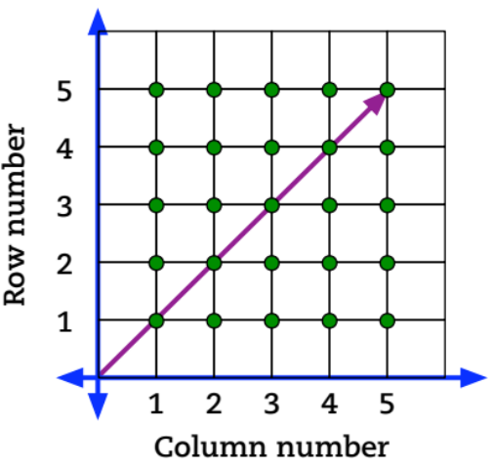

2.5 Proportional Reasoning Every Day
We have seen that algebra arises in making introductions, the 100s chart, number and magic number puzzles, children’s literature, and Aesop’s fable. Now we examine contexts that arise in our daily experiences.

Activity: Recipes and Proportional Reasoning
A proportional relationship that frequently arises in daily life is scaling recipes. As you work on the student page, think about these questions: What does slope mean in this context? How can we find the slope in each representation, context, table, graph, and equation? How are the slopes for each of the ingredients in the guacamole recipe related?
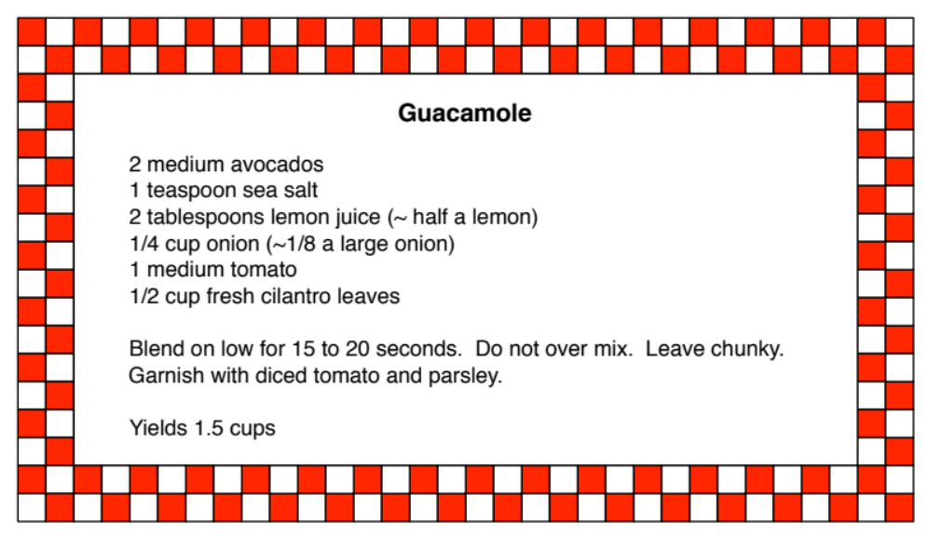
Proportional Reasoning with Recipes
1. a. Have you had to make more or less of a recipe? Why did you alter it?
b. What did you do to rescale the recipe?
2. Use the guacamole recipe. Determine the amount of each ingredient you need for the number of recipes of guacamole shown in the first column. Complete the table below.

 | Ingredients
Amount needed for n recipes with n = | Avocados | Tomatoes | Lemons | Onions
$$\frac{1}{2}$$
1 | 2 | 1 | $$\frac{1}{2}$$ | $$\frac{1}{8}$$
2
3
4
n
3. What patterns do you notice in the table?

4. Graph the data by plotting the points, (Number of recipes, amount of ingredient needed).
a. What scale should you
use for each axis? How
did you decide what the
scale should be?

b. Label the scale on each
axis. Write a title on
each axis showing what
it represents.
c. Graph each ingredient
using a different color.
Label each graph with
the ingredient it
represents.

5. Compare the graphs. What do you notice? List as many relationships as you can.

6. For each ingredient, find an equation that will predict the amount you will need for an unknown number of recipes. Write the equations in the last row of the table.
7. You have 5 avocados.
a. How many recipes of guacamole can you make and use all of them?
b. How can you tell from the graph?
c. How can you tell from the table?
d. How can you tell from the equation?
8. You have 1 onion but want to save half of the onion for salsa.
a. How many recipes of guacamole can you make?
b. How can you tell from the table?
c. How can you tell from the graph?
d. How can you tell from the equation?
9. a. What does slope mean in the context of number of recipes versus amount of ingredients?
b. How can you find the slope from a table? From a graph? From the equation? From the recipe?
c. How are the slopes related for the ingredients in the guacamole recipe?

Activity: Where Else Do You Use Proportional Reasoning?
We have seen that the relationship between distance and time is proportional when speed is constant. We have also seen that proportional reasoning arises in rescaling recipes. What other relationships are proportional? Work with your group to identify at least 3 other proportional relationships. Complete the student page, Proportional Linear Function Example, for each relationship your group identifies.
Once you have completed the above, look for common properties among the examples you found. With your group, answer these questions:
- What is a proportional relationship?
- What properties do all proportional relationships have in common?
- For a proportional relationship, how can you find the slope from:
  - A table?
  - A graph?
  - An equation?
  - A context?
Choose one or two of your group’s proportional relationships to share with the class. Post them as directed by your teacher. Groups will cycle through them and indicate with a checkmark if they agree with your work. They will draw a circle if they have a question about your work.

Proportional Linear Function Example
Title:
Description:

Independent variable (description and variable):
Dependent variable (description and variable):
1. Create a table. Briefly description the independent variable in the cell above x. Briefly describe the dependent variable in the cell above y. Choose eight reasonable x-values (not all consecutive); write them in the first column of the table. Find the corresponding
y-values; write them in the second column of the table.
x | y
2. Plot the data on the graph at
right. Label accurate scales for
both x and y so that you use
most of the graph. Write titles
on each axis to show what
quantity each axis represents.
3. Find an equation.
a. How can you get the value
of the dependent variable
from the value of the
independent variable?
b. Write the relationship in problem 3a as an equation.
4. Answer these questions on the back of this page.
a. What is the slope of the graph?
b. How is the slope of the graph related to the equation?
c. How is the slope of the graph related to the table?
d. How is the slope of the graph related to the context?

2.5 Homework
1. A step conversion chart indicates that if you walk 4 miles per hour, you would take approximately 140 steps per minute. The same chart shows that if you cycle at 15 miles per hour, you would take the equivalent of 160 steps per minute.
a. Complete the table for one of the sports.
 | Number of steps taken
Number of Minutes | Walking at 4 mph | Cycling at 15 mph
1 | 140 | 160
2
3
4
5
10
20
60
m
b. Write an equation that fits your data in the last row of the table. Tell how you know your equation is correct.
c. Plot the data. Label scales and titles for each axis.
d. For your choice of exercise, how many minutes would you have to exercise to take the equivalent of 10,000 steps? Show your work.
2. A step conversion chart showed the following information:
Cycling at C miles per hour | Equivalent number, N, of steps per minute of exercise
5 | 55
10 | 93
15 | 160
20 | 200
a. Comparing C to N, is the relationship linear or non-linear?
b. How can you tell from the table?
c. How can you tell from a graph?
3. When you eat at a sit-down restaurant, it is customary to leave a tip to reward the server for good service. Suppose you always leave a 15% tip.
a. Write in words how you would determine how much to tip a server if the amount of your check is $30.
b. What if your check is $40?
c. What if your check is D dollars?
d. Write an algebraic expression to compute the amount of the tip to leave the server if the tip is 15% of the check and your check is D dollars.
e. How can you quickly estimate a 15% tip?
f. What changes in the expression you wrote in problem 3d if you leave a 20% tip?
g. How can you quickly estimate a 20% tip?
4. A dog’s life span is a fraction of time compared to that of humans. The table below shows a how a dog’s age might be adjusted to compare to a human’s age.
Number of actual years of life, y | 1 | 2 | 3 | 4 | 5 | 6 | 7 | 8 | y
Comparative human age (dog years), d | 6.5 | 13 | 19.5 | 26
a. Find the pattern and fill in the missing values in the table.
b. What expression can you use to find a comparative human age for a dog that is y actual years old?
c. Would you call a dog middle-aged if she is 7 actual years old? Why or why not?
5. a. Most of the rest of the world uses kilograms rather than pounds.
Note: 1 kg = 2.2 pounds = 2.2 lbs.
b. When traveling in the United Kingdom, I bought 2 kg of bananas. How many pounds of bananas is this?
c. Fill in the table below:
Kilograms | 0.5 | 1 | 1.5 | 2 | 2.5 | 3 | 3.5 | 4 | 10 | k
Pounds |  |  |  |  |  |  |  |  |  | p
d. Write an equation you can use to convert kilograms to pounds exactly.
e. When you buy bananas, how many pounds do you usually buy? (Three medium bananas weigh approximately a pound.) How many kg of bananas is this number of pounds?
6. JoAnn Fabrics regularly runs sales. A recent flier included a coupon for 60% + 15% off custom framing. How much would you pay for a framing bill of x dollars? Explain.
7. Ashley loves Salted Caramel Mocha coffee. She orders her favorite with either 2% or coconut milk and occasionally also orders whipped cream. The number of calories for each type of drink depends on the number of ounces of coffee in the size of cup she buys.
Number of  ounces of coffee | Number of calories, C
Number of  ounces of coffee | With 2% milk | With 2% milk and whipped cream | With coconut milk
8 | 180 | 280 | 160
12 | 270 | 370 | 240
16 | 360 | 460 | 320
20 | 450 | 550 | 400
30
x

a. Plot all three sets of data on the same coordinate plane. Connect the points for each data set. Label each graph to match the data set: 2% milk, 2% milk with whipped cream, or coconut milk.
b. For each proportional relationship, in the last row of the table, write equations that fit the data. Tell how you know your equations are correct based on the context.
c. Suppose the coffee shop offered a 30-ounce cup of coffee. If Ashley ordered this size, what would be the number of calories? Include this information in the table.
d. Is there a data set that is not proportional? If so, which one? How do you know?
8. Each of the relationships can be modeled by a linear equation. For each set of data in problems 1 through 7:
a. Graph the data on a separate coordinate plane. Find the slope of the graph. Write the equation under the graph.
b. How does the slope of the graph relate to the equation?
c. How can you find the slope of the graph using the table?
9. a. Why do you think the examples in problems 1 through 7 are called linear relationships?
b. Think about the examples above, scaling recipes, and relationships discussed in class. What are some general properties of linear relationships?
c. Think of another linear relationship that arises in your life. Describe the relationship. Why do you think it is linear?
10. Practice using Desmos to graph the examples in problems 1 through 7. If you need more help, click on the ? icon (Help) in the upper right corner of the Desmos graphing screen. Choose Tables for a tutorial on entering and graphing data. Choose Sliders to see what these do. Use a slider with the equation, y = mx to fit your data. Explain why the equation you find makes sense for your data.

2.6 Distinguishing Proportional Relationships from Other Linear Relationships

Activity: Giving the Tortoise a Head Start
So far, we have seen several examples of proportional linear relationships. In each case, the graph modeling the relationship went through the origin. We return to The Hare and the Tortoise to consider other possibilities. Giving the Tortoise a Head Start introduces other linear relationships.
Giving the Tortoise a Head Start
The hare challenged the tortoise to another race. He gave the tortoise a head start to make the race seem fair. They used the same 1000-meter course and started the race together.

1. a. The tortoise started the race 500 meters from the Starting Line. As in the original race, she plodded at a rate of 20 meters per minute. On the grid, draw a graph of the tortoise’s distance from the starting line over the time it took her to complete the race.
b. The hare ran at a steady rate of 250 meters per minute throughout the race. He stopped only after he crossed the Finish Line. On the same grid, draw a graph of the hare’s distance from the starting line over the time it took him to complete the race.
c. Who won the race? How do you know?
d. Suppose the tortoise started the race 100 meters from the Finish Line. Who would win the race? Explain. Draw the graph on the axes below.
2. Complete all three columns in the table to compare the tortoise’s distance from the Starting Line at the same time for these races. For each race, use a different color to highlight the time at which the tortoise reached the Finish Line. Use the same color to highlight the corresponding graph. Recall: In the original race, the tortoise started at the Starting Line.
 | The tortoise’s distance in meters from the Starting Line
Time elapsed in minutes | Original Race | Race in problems 1a | Race in problem 1d
0 | 0
1 | 20
2
3
4
5
10
20
30
40
50
3. Graph the tortoise’s races from the table in problem 2 on the same coordinate plane. How are the graphs related?
With your group, discuss what new information about linear relationships is gained from the student page, Giving Tortoise a Head Start. Outline what you have learned about linear relationships through the progression of activities: The Hare and the Tortoise, Trodding Tortoise, Hopping Hare, and Giving the Tortoise a Head Start. Ask any questions you have remaining.
4. Study the table and the graphs.
a. For each graph and corresponding data set, find an equation to model the graph and data.
b. What do the equations have in common? Explain.
c. What is different in each of the equations? What accounts for the differences?
d. How does Tortoise’s head start show up in each equation? Why does this make sense?
5. You have studied the idea of “head start” in linear relationships in previous mathematics classes. What is the mathematical name for the “head start” value in a linear equation?

Activity: Finding Equations from Tables and Interpreting Slope and y-Intercept
Sometimes students find it difficult to determine an equation from a table, a graph, or a story. These three representations are highly linked. If you can find a table from a graph or a story, you can always find an equation from the patterns in the table. The student page, Finding Equations from Tables and Interpreting Slope and y-Intercept, gives you a few tools to help you find an equation from a table. Though initially, this work might seem time-consuming, complete it as directed. It is important not to simplify too soon so that you can see how patterns are forming. You will find short-cuts soon enough.
Work with your group to complete the student page, Finding Equations from Tables and Interpreting Slope and y-Intercept. Pay close attention to how you can find equations from tables. Be ready to answer these questions:
- How are recursive and explicit equations related?
- How does this activity help you distinguish proportional linear relationships from other linear relationships?

Finding Equations from Tables and Interpreting Slope and y-Intercept
1. a. What patterns do you see in Table A? Table B? (Don’t complete the tables yet.)
Table A Table B
x | y | Another way to write y |  | x | y | Another way to write y
0 | 0 | 0 |  | 0 | 5 | 5
1 | 3 | 0 + 3 |  | 1 | 8 | 5 + 3
2 | 6 | 0 + 3 + 3 |  | 2 | 11
3 | 9 |  |  | 3 | 14
4 | 12 |  |  | 4 | 17
5 |  |  |  | 5
6 |  |  |  | 6
27 |  |  |  | 27
108 |  |  |  | 108
b. How are the tables similar? Show your work and explain.
c. How are the tables different? Show your work and explain.
2. Graph the data in both tables on the same pair of axes. What do you notice? Does your observation seem reasonable? Explain.
3. a. In the column labeled, Another way to write y, show how the y-values in the table build from the y-value when x = 0. This is the starting y-value. Do not simplify at any step. Continue extending the table to find the y-values for x = 5 and x = 6.
b. What patterns are evident from your work in problem 3a?
Table A:

Table B:
c. A recursive pattern is a rule that tells you the starting number of a pattern and how the pattern continues. It is likely that recursive patterns are the first thing you notice when working with tables. For each table in problem 1, write a recursive rule to find the
y-values in the table. Don’t forget to list a starting y-value and what you have to do to get successive y-values in the table.
Table A:

Table B:
4. An explicit equation is a rule that allows you to find a value for y directly from the corresponding value for x. In the recursive pattern, you found that you added the same number each time. Let’s call this number a constant. In the table, for a particular value of x, how many times did you add the constant to get the value of y for that value of x? Use this information to write explicit equations for each table in problem 1. Use the equations to complete the tables.
Table A:

Table B:
5. How does each explicit equation relate to each recursive equation?

6. Repeat problems 1 through 4 for the tables below.
Table C Table D
x | y | Another way to write y |  | x | y | Another way to write y
0 | 9 |  |  | 1 | 6
1 | 7 |  |  | 2 | 8
2 | 5 |  |  | 3 | 10
3 | 3 |  |  | 4 | 12
4 | 1 |  |  | 5 | 14
5 | –1 |  |  | 6
6 | –3 |  |  | 7
Recursive rule:
Explicit equation:
7. Are you tired of filling out the column, Another way to write y? Now that you’ve experienced the constant growth of a linear relationship, you can simplify the process. Study Table E. Notice how the process below simplifies the work you did in problems 1a and 6. In this process you find the difference between two consecutive y-values instead of writing each y-value in terms of the starting y-value. For Table E:
a. How many times do you add 4 to the starting y-value to get the y-value when x = 3?
b. How many times do you add 4 to the starting y-value to get the y-value when x = 6?
c. Find an explicit equation to fit the table. How do you know your equation is correct?
d. Use the same process to analyze Table F. Find an explicit equation to fit the table.

Table E Table F
x | y | Change in y |  | x | y | Change in y
0 | 7 |  |  | 0 | 15
0 | 7 | 4 |  | 0 | 15
1 | 11 | 4 |  | 1 | 12
1 | 11 | 4 |  | 1 | 12
2 | 15 | 4 |  | 2 | 9
2 | 15 | 4 |  | 2 | 9
3 | 19 | 4 |  | 3 | 6
3 | 19 | 4 |  | 3 | 6
4 | 23 | 4 |  | 4 | 3
4 | 23 | 4 |  | 4 | 3
5 | 27 | 4 |  | 5 | 0
5 | 27 | 4 |  | 5 | 0
6 | 31 | 4 |  | 6 | –3
8. There are two important numbers in a linear equation.
a. One is the slope. How can you find the slope from a table? How does it show up in the equation?
b. The other number is called the y-intercept. What is a y-intercept?
c. How can you find the y-intercept from a table? How does it show up in the equation?

2.6 Homework
1. Extend the work from, Finding Equations from Tables and Interpreting Slope and y-Intercept, to finding equations from graphs and contexts by completing the following student page.
Finding Equations from Graphs and Contexts, Interpreting Slope and y-Intercept
1. Compare the graphs. Which ones are related to each other? How are they related?
(Note: Each graph is labeled along the left side of the graph.)

A

B

C

D

2. a. Complete a table for each graph.
Graph A Graph B Graph C Graph D
x | y |  | x | y |  | x | y |  | x | y
0 |  |  | 0 |  |  | 0 |  |  | 0
1 |  |  | 1 |  |  | 1 |  |  | 1
2 |  |  | 2 |  |  | 2 |  |  | 2
3 |  |  | 3 |  |  | 3 |  |  | 3
4 |  |  | 4 |  |  | 4 |  |  | 4
5 |  |  | 5 |  |  | 5 |  |  | 5
6 |  |  | 6 |  |  | 6 |  |  | 6

b. Determine a recursive pattern for each table.
c. Use the recursive rule to find an explicit equation for each graph. Write the recursive pattern and the equation under each table.

3. a. What is slope? (See Trodding Tortoise, problem 4e if you don’t recall.)
b. How can you find the slope of a graph from a table?
c. How can you find the slope of a graph from an equation?
d. How can you find the slope directly from a graph? Show how the slope arises from the graph in each case.
4. a. What is the y-intercept?
b. How can you find the y-intercept from a table?
c. How can you find the y-intercept from an equation?
d. How can you find the y-intercept from a graph?
5. Consider the contexts that follow.
a. Create a table for each context.
b. Graph the data in each table.
c. Determine a recursive rule then an explicit equation that fits each context.
Context A: Raffle tickets are $0.50 each. How much will you pay for T tickets?
Context B: You have $6 to buy ride tickets at a fair. Each ticket costs $1. How much money do you have after you purchase T tickets?
Context C: It costs $2 to get into a dance. At the dance you can buy glasses of punch for $0.50 each. How much will you spend for the dance and punch after buying G glasses of punch?
Context D: The Rowing Team is selling cookies for $1 each. A friend is selling the cookies and allows you to pay later for cookies you buy beyond the $3 you have in your pocket. How much will you pay your friend if you buy C cookies? (Negative dollars are dollars you will pay your friend after the cookie sale.)
6. a. How can you find slope from a context?
b. How can you find the y-intercept from a context?
c. What does the slope mean in the contexts above?
d. What does the y-intercept mean in the contexts above?
7. Match the contexts in problem 6 to the graphs in problem 1. How do you know you are right?
Graph A Context A
Graph B Context B
Graph C Context C
Graph D Context D
8. Some students say that you can find the slope from a table by dividing the value of y by the value of x for a single data point.
a. Does this method ever work? If so, for which of the examples above will this method work? Why does the method work?
b. Try this method for finding slope on the table for Graph B. Does the method work in this case? Why or why not?
c. For which of the examples above will this method for finding slope fail? Why does it fail?

2. Look for uses of linear equations in your daily life and write a problem similar to those in problem 5 of the student page, Finding Equations from Graphs and Contexts, Interpreting Slope and y-Intercept. The problem can come from a newspaper, some other media source, through a table, graph, or story. It must be specific enough for others to determine an equation from your example. Find at least 3 examples, one of which includes the point
(0, 0). Write your examples on index cards to pass around in class.
3. For each problem in the table below, complete parts 3c through 3f. Complete parts 3a and 3b for the problems to which they pertain.
a. Fill-in the first 5 missing values in the tables (first two and last two problems).
b. Write a story to go with the two completed tables provided.
c. Identify the slope. State the meaning of the slope in context.
d. Determine an equation. Make sure your equation fits the data.
e. Tell how you know your equation is correct in terms of the story or graph.
f. Determine and write the last value in each table.
Story | Table | Slope, Equation, and Explanation
Nasredinne drinks 64 ounces of water each day. What is the total amount of water, y, he has consumed by the end of x days?
  x | y
  1
  2
  3
  4
  5
  28
Jessa jumps rope for $\frac{3}{4}$ hours per day. What is the total number of hours, y, she has jumped rope by the end of x days?
  x | y
  1
  2
  3
  4
  5
  31
x | y
1 | 1.2
2 | 2.4
3 | 3.6
4 | 4.8
5 | 6.0
17

Story | Table | Slope, Equation, and Explanation
x | y
1 | 7
2 | 14
3 | 21
4 | 28
5 | 35
43

Graph | Table  Do not estimate. Use grid points to fill in the first 5 values of each table. | Slope, Equation, and Explanation
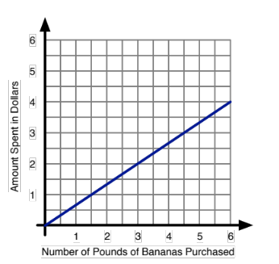
  x | y
  8
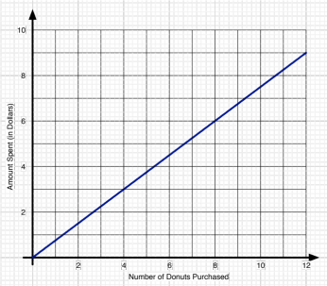
  x | y
  32

4. Find two related data sets (or create them from real contexts such as a menu). One data set must be a proportional linear relationship. The other data set must be linear but not a proportional linear relationship. Answer the following questions for each data set:
a. Present your scenario. Complete the table to fit the scenario.
b. Create a graph using an electronic tool. Label the horizontal (x) axis and the vertical (y) axis. Plot the data in problem 4a. Connect the points in your graph. Print the graph.
c. Describe the shape and important features of the graph you created.
d. Is the relationship between x and y linear? Why or why not?
e. How can you tell from the graph whether or not the linear function is proportional? Explain.
f. Write an equation that gives y in terms of x.
g. Compare the data you found for the proportional linear function with the data you found for the linear function. What accounts for the differences between the data sets?

2.7 The Meanings of Slope and y-Intercept, Connecting Graphs and Equations

Activity: Linear Functions with Desmos – Slopes and y-Intercepts
Use Desmos to complete the following investigation. Be ready to discuss your findings with your group and with the class. Find Desmos at: https://www.desmos.com/calculator.

Linear Functions with Desmos – Slopes and y-Intercepts
1. Type y = mx + b into the entry line on the left side of the screen. Notice that Desmos allows you to create sliders for m and b. Do this by clicking the “all” button.
2. Set b = 0. Play with m. Describe the appearance of the line when:
a. m = 0 b. m < 0 c. m > 0
d. What effect does changing m have on the graph of y = mx?
e. Why does m have the effect you say it does?
3. Graph the line y = x by typing it into the next entry line on the left side of the screen.
4. a. Which line is steeper, one with a slope of 2 or one with a slope of 0.25? Why?
b. When b = 0, how do each of these lines compare with y = x? Why is this sensible?
5. a. Which line is steeper, one with a slope of –2 or one with a slope of 0.25? Why?
b. When b = 0, how do each of these lines compare with y = x? Why is this sensible?
6. Let b = 0.
a. What is the equation of the line when m = 2?
b. What is the equation of the line when m = 0.25?
c. What is the equation of the line when m = –2?
7. Set m = 1. Play with b. Describe the appearance of the line when:
a. b = 0 b. b < 0 c. b > 0
d. What effect does changing b have on the graph of y = mx + b?
e. Which direction is the graph moving, up and down or left and right? How do you know?
8. a. In your own words, what is slope?
b. State everything you can about the value of m and the appearance of the graph of
y = mx + b.
c. In your own words, what is the y-intercept?
b. State everything you can about the value of b and the appearance of the graph of
y = mx + b.
9. Predict the appearance of the graph of each of the following lines. Do not draw them yet.
a. y = 0.5x + 1 b. y = –x – 2 c. y = 3x – 0.5
d. Hold an empty page protector against your computer/tablet screen. Use the viewing window on your screen and hand-draw each graph using a dry erase marker. (Trace the x- and y-axes on the page protector so you can accurately reposition the graphs if the page protector slides.)
e. Without changing the viewing window, electronically graph each of the equations in 9a-c. Compare the Desmos graphs with your hand-drawn graphs. If any graph is incorrect, decide what caused the error.
10. Summarize your work. Answer the following questions and any others that occur to you.
a. Given a graph, how can you determine its slope?
b. In an equation of a line, y = mx + b, which letter, m or b, represents the slope? Explain.
d. Given a graph, how can you determine its y-intercept?
e. In an equation of a line, y = mx + b, which letter, m or b, represents the y-intercept? Explain.

Activity: Polygraphs: Linear with Desmos
Polygraphs: Linear is very much like the game, Guess Who? One partner picks a graph, the other partner asks questions to determine which graph the first person chose. You will ask questions that can be answered with “yes” or “no” to try to eliminate graphs, finally determining the one chosen by your partner. Desmos gives you a sample game to play then randomly chooses a partner for you.
Get on student.desmos.com. Enter our Polygraphs: Linear Class Code: _________. Play the game for a few rounds, until your teacher asks you to stop.
Which questions help the guesser determine the correct graph? Which questions help the graph chooser determine which graphs the guesser is eliminating? Which questions are not helpful to the guesser or chooser?
Polygraph: Lines, Part 2 helps you move from informal language about lines to language that is more precise and less ambiguous.
Get on student.desmos.com. Enter our Polygraphs: Linear, Part 2 Class Code: _________. Complete the activity.

2.7 Homework
1. Complete the student page, Finding Equations from Representations on pages 93 and 94. Be ready to share your work with your group and the class.
2. Complete the student page, Slope and y-Intercept in Context on pages 95 and 96. Be ready to share your work with your group and the class.
3. Study the tables below. Notice that the y-intercept is not an element in any of the tables. Figure out a way to find an equation to fit each. Describe your process. Careful! How is x changing in these tables?
x | y |  | x | y |  | x | y
4 | 5 |  | 3 | 4 |  | 6 | 12
8 | 7 |  | 6 | 8 |  | 8 | 9
12 | 9 |  | 9 | 12 |  | 10 | 6
16 | 11 |  | 12 | 16 |  | 12 | 3
20 | 13 |  | 15 | 20 |  | 14 | 0
4. Summarize your understanding of linear functions. Answer the questions below and any others that occur to you. Be ready to ask questions over any concepts that are still unfamiliar to you.
a. What do you know about the slope?
b. How can you determine the slope from a table?
c. How can you determine the slope from a graph?
d. How can you determine the slope from an equation?
e. How can you determine the slope from a context or story?
f. What do you know about the y-intercept?
g. How can you determine the y-intercept from a table?
h. How can you determine the y-intercept from a graph?
i. How can you determine the y-intercept from an equation?
j. How can you determine the y-intercept from a context or story?
5. Work on the Linear Function Card Sort on pages 96 through 98. You may discuss your work with other members of your group. You will be submitting your individual work as well as group work. Create and print graphs electronically (Desmos is recommended). If your handwriting is hard to read, type your responses.
Due in class on: ____________________.
On the due date, each group will collect:
1) The individual work completed by group members,
2) Individual reflections on group functioning (problem 6 below), and
3) The following group reflection, Reflecting on Your Group’s Work on the Linear Function Card Sort.
Place the group reflection on top of the packet (item 3), attach the individual work to it (items 1 and 2), then the group’s work on the Linear Function Card Sort.
6. Be prepared to submit your individual answers to questions 6a through 6h on the Linear Function Card Sort due date. Read the questions ahead in preparation.
a. Approximately how much time did you spend completing the Function Card Sort? Did you work on it by yourself? Did you bring your individual work to group meetings?
b. Did your group work together on the Linear Function Card Sort? How did you communicate, face-to-face, through social media? Explain.
c. Did any of your group members only work on the card sort when you were together?
d. What steps can your group take to work together more productively?
e. Do you work well together in class? Explain.
f. Do you work well together outside of class? Elaborate.
g. If you are dissatisfied with your group, what would need to happen for you to be satisfied with your group?
h. Would you like to stay with your current group? If not, with whom would you like to work? Why?

Finding Equations from Representations
Directions: Tables, graphs (use grid points!), and stories are provided. For each case:
1. Find the slope. 2. Find the y-intercept. 3. Write an equation.
4. Explain how you know the slope and y-intercept are correct. Check 2 points in your equation to show it is correct.
Linear Function Representation | Say how you know you are correct. |  | Equation
Linear Function Representation | Slope | y-intercept | Equation
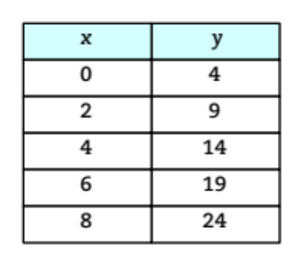
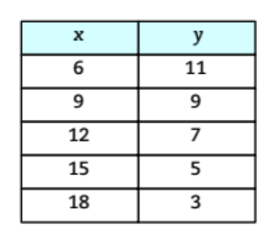
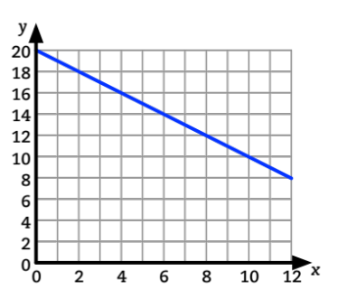
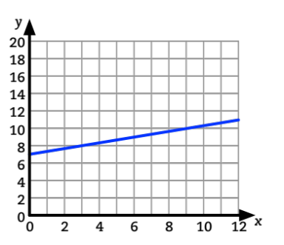

Linear Function Representation | Slope | y-intercept | Equation
Hannah shelters her dog at Happy Trails Kennel while she is out of town. Happy Trails requires Hannah to begin each month with $200 in her account and charges her account $15 each day her dog stays at the kennel. What amount, A, will Hannah have in her account at the end of the month if her dog stays at the kennel for d days?
What is the total cost, C, of x months of use of the Fitness Fun health club? Fitness Fun charges a $75 initiation fee plus $20 per month.

Slope and y-Intercept in Context
1. For each story:
a. Create a table.
b. Plot the data in the table electronically.
c. Find the slope and y-intercept. Explain how you know each is correct based on the context.
d. Determine an equation.
e. Graph the equation electronically on the same graph as in problem 1b to verify the equation fits the data.
Story | Table | Equation | How do you know you’re right?
Story | Table | Equation | Slope | Intercept
At a comedy club, the entrance fee is $15. Beverages cost $5 each. How much will you pay overall including entrance fee and x beverages?
  x | y
  1
  2
  3
  4
  5
  6
  x
Charity always leaves a generous tip when she eats out. She leaves a 15% tip plus $2 regardless of the amount of the bill. How much tip will she leave based on the amount of the bill?
  x | y
  1
  2
  3
  4
  5
  6
  x
Alan really likes apples. He pays $1.25 for each apple he buys at the Commons. He has a food card with $50 on it that he only uses to purchase apples. What is the amount, y, available on the card after purchasing x apples?
  x | y
  1
  2
  3
  4
  5
  6
  x
To park in a downtown parking lot, you pay $60 for a sticker giving you the privilege of parking in the lot. The daily charge (once you have the sticker) is $5/day. How much have you paid to park in the lot after x days?
  x | y
  1
  2
  3
  4
  5
  6
  x

Barnes and Noble charges $25 for a yearly membership. B&N members get a 20% discount on every purchase. How much will a member pay per year if she buys x dollars worth of books at Barnes and Noble?
  x | y
  100
  200
  300
  400
  500
  600
  x
Daevon plays basketball at the Y. The Y charges $52 each month plus a $20 initiation fee. How much will Daevon pay for x months of use of  the Y?
  x | y
  1
  2
  3
  4
  5
  6
  x
2. Create two different stories that relate to your life. One story must have a negative slope. The other must have a positive slope. Fill-in the table for your stories.
x | y
1
2
3
4
5
6
x

x | y
1
2
3
4
5
6
x

Linear Function Card Sort
1. a. Cut apart the cards on the next page.
b. Sort the cards into 4 sets so that each card in a set represents the same linear function. Each set contains 3 cards, one for each of 3 different representations.
c. For each card set:
- List the card numbers for cards that represent the same linear function in the appropriate cells.
- One representation is missing for each card set. Put an X in the cell to show the representation is missing for that card set.
 |  | Include card numbers for these representations.
Card Set | Equation | Graph | Table | Story
1 | y = 8x + 5
2 | y = –0.75x + 20
3 | y = 5x + 8
4 | y = 0.5x + 8
5 | X
Cards that don’t fit other card sets.

2. For each missing representation, create a card that fits the linear function card set. For example, if the card set is missing a table, create a table that fits the linear function. Explain how you know your representation fits the linear function.
3. There are 3 cards that do not fit any of the 3-card sets. For each of these cards:
a. Write the number of the card in the final row of the table in the appropriate cell. (All of the equations are listed in the table. One equation doesn’t fit any card set. Write its card number in the last row.)
b. If the card does not show an equation, find an equation that fits the card.
c. Create a story in a real context that fits the card. The other word problems in the card sort can serve as examples.
Attach this sheet to your work.
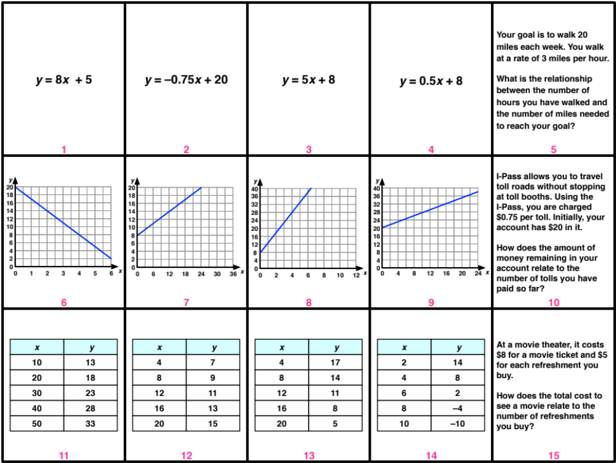
Linear Function Card Sort Cards
Reflecting on Your Group’s Work on the Linear Function Card Sort
1. As a group, share your Linear Function Card Sort responses.
2. For each cell in the table below, write down every card number each group member wrote in that cell. If more than one group member had the same card number for the same cell, write it only once.

 |  | Include card numbers for these representations.
Card Set | Equation | Graph | Table | Story
1 | y = 8x + 5
2 | y = –0.75x + 20
3 | y = 5x + 8
4 | y = 0.5x + 8
5 | X
Cards that don’t fit other card sets.
3. Resolve any differences in solutions your group members found. Do not erase any of your work on this page or on your individual work. Instead, in the table above, circle the solutions your group agrees are correct and indicate how you resolved any differences.

4. Are there any cards you could not sort or are still unsure of the sorting? Are there any disagreements your group could not resolve? List the card numbers here. We will work on these together as a class.

2.8 Linear Functions: Big Ideas

Activity: Big Ideas – Slope and y-Intercept
Let’s take some time to revisit and synthesize what you’ve been exploring about linear functions from this chapter. Use Desmos on your laptop, tablet, or smart phone. Be ready to share your findings and to demonstrate using the classroom computer.
By now you have discovered that all linear equations can be represented generally by the equation, y = mx + b, where x and y are variables and m and b represent known numbers (m and b are called parameters).
1. Type this general form of a linear equation into Desmos. Create sliders for m and b. For questions 1a and 1c, use one or two rounds of Roundtable (see page 10 in Chapter 1) to share everything you have learned. Explain each item in your list as you create it.
a. Let b = 0 and play with m. List everything you can about the effect of m on the graph of
y = mx.
b. Revisit your list. If you have not already answered the following, do so now. Explain!
What happens to the graph of y = mx when:

- m > 0?
- m < 0?
- |m| is large?
- |m| is close to zero?

c. Let m = 1 and play with b. List everything you can about the effect of b on the graph of
y = mx + b.
d. Revisit your list. If you have not already answered the following, do so now.
What happens to the graph of y = mx + b when:

- b > 0?
- b < 0?
- |b| is large?
- |b| is close to zero?

- How is the graph of y = mx + b moving as you change the value of b?
- Why is the graph moving as you say it does?
2. a. Place a page protector over the screen on your electronic tool. Trace the x- and y-axes on the page protector. By hand, graph the following equations. Explain how you drew each graph so that you know it is accurate.
i. y = 2x + 4 ii. y = 0.5x – 3 iii. y = –x – 1
b. Once all group members are satisfied with the three hand-drawn graphs from problem 2a, graph them electronically. Was each hand-drawn graph accurate? If not, what needs to be fixed? What were you thinking when you drew each graph? What do you now know? Turn off the electronic graph and redraw the graph using what you now know. Recheck.
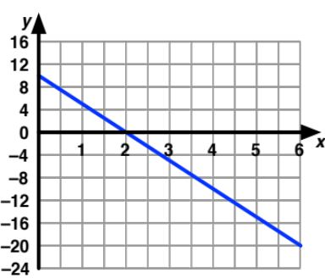
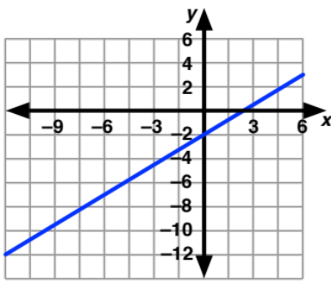
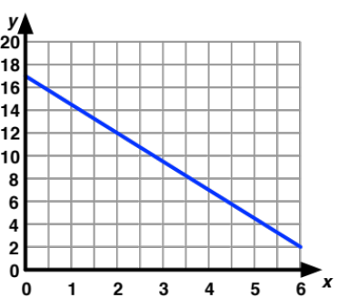
3. Study the graphs. Find an equation for each graph. Do not estimate; use grid points to find each equation accurately. In each case, explain how you know your choices of slope and
y-intercept are correct.

4. Study the tables. For each table, find an equation to fit the data. In each case, explain how you know your choices of slope and y-intercept are correct.
x | y |  | x | y |  | x | y
4 | –5 |  | 8 | 3 |  | 1922 | 450
8 | –7 |  | 10 | 11 |  | 1928 | 435
12 | –9 |  | 12 | 19 |  | 1934 | 420
16 | –11 |  | 14 | 27 |  | 1940 | 405
20 | –13 |  | 16 | 35 |  | 1946 | 390
5. Study each context. For each context, find an equation. In each case, explain how you know your choices of slope and y-intercept are correct.
a. Fia earns 3 points every time she finds a star in her Dora the Explorer game. She earns a one-time bonus of 50 points in each level for finding a banana for her monkey friend, Boots. Based on the number of stars she finds, how many points will Fia earn in a level if she always finds the banana?
b. Valen earns $5 each week for doing his chores. Each time his mom has to remind him, there is a $0.50 deduction from his allowance. How much will Valen earn in a week based on the number of times he needs to be reminded to do his chores?
c. Jackson has $18. Each month, he pays $4 to stream music on his iPod. How much does he have or owe based on the number of months he streams music?
6. Complete the table below. In each case explain how you find the slope and the y-intercept in each representation.
In y = mx + b | Table | Graph | Context
Slope, m
y-intercept, b

2.8 Homework
1. Study the graph at right. Answer questions 1a through 1f for this line.
a. What is an intercept? How can you find an intercept on a graph?
b. Which point is the y-intercept? Write the point as an ordered pair, (x, y). How do you know this point is the y-intercept?
c. Which point is the x-intercept? Write the point as an ordered pair, (x, y). How do you know this point is the x-intercept?

d. Find five points grid points on the graph. Do not estimate. Write them in the table.
x | 0
y |  | 0
e. Find the slope of the line through these points. Show or explain your work.
f. Write an equation for the line.
2. A line has slope, m = 0.75. Its y-intercept is the point (0, 2).
a. Accurately graph the line on the coordinate axes in problem 1.
b. Write an equation for the line.
3. The slope of a line is –2. One point on the line is (–3, 4).
a. Accurately graph the line on the grid in problem 1.
b. Find the y-intercept and the equation of the line.
c. How do you know your equation is correct?
4. Find an equation to fit each data set. Show and explain your work. Fill in the last 2 rows of each table to fit the equation you find.
x | y |  | x | y |  | x | y |  | x | y
–3 | 5 |  | 4 | 17 |  | 120 | 15 |  | 30 | 6
–2 | 11 |  | 12 | 6 |  | 125 | 18 |  | 32 | 6.5
–1 | 17 |  | 20 | –5 |  | 130 | 21 |  | 34 | 7
0 | 23 |  | 28 | –16 |  | 135 | 24 |  | 36 | 7.5
1 | 29 |  | 36 | –27 |  | 140 | 27 |  | 38 | 8
2 |  |  | 44 |  |  | 145 |  |  | 40
17 |  |  | 100 |  |  | 200 |  |  | 150
5. Write stories for two of the tables in problem 4. Explain how each story fits the corresponding table.
6. Complete the student page, Distinguishing Linear from Other Functions. Be ready to discuss your work with your group and with the class.
Distinguishing Linear from Other Functions
1. What do you know about linear equations? Give brief answers now and think about these questions as you work on the problems below.
a. What patterns would you see in a table of data that can be modeled by a linear equation?

b. How can you tell a graph can be modeled by a linear equation?

c. What does an equation of a linear equation look like?

d. How can you tell a story can be modeled by a linear equation?

2. Study the data sets. Label each data set as linear or non-linear. Explain your choice.
x | y |  | x | y |  | x | y
–5 | –14 |  | –5 | 0.03125 |  | –5 | 25
–4 | –12 |  | –4 | 0.0625 |  | –4 | 16
–3 | –10 |  | –3 | 0.125 |  | –3 | 9
–2 | –8 |  | –2 | 0.25 |  | –2 | 4
–1 | –6 |  | –1 | 0.5 |  | –1 | 1
0 | –4 |  | 0 | 1 |  | 0 | 0
1 | –2 |  | 1 | 2 |  | 1 | 1
2 | 0 |  | 2 | 4 |  | 2 | 4
3 | 2 |  | 3 | 8 |  | 3 | 9
4 | 4 |  | 4 | 16 |  | 4 | 16
5 | 6 |  | 5 | 32 |  | 5 | 25
3. Categorize each graph as linear or non-linear. Explain your choice.
Graph 4a | Graph 4b | Graph 4c

4. Gather data for each story. Label each data set as linear or non-linear. Explain your
choice.
Story 3a |  |  | Story 3b |  |  | Story 3c
Geppetto carved Pinocchio a 2-inch long nose. Each time Pinocchio tells a lie, his nose grows 3 inches. How long will his nose be after 1 lie? 2 lies? 3 lies? L lies? |  |  | Geppetto carved Pinocchio a 2-inch long nose. Each time Pinocchio tells a lie, his nose doubles in length. How long will his nose be after 1 lie? 2 lies? 3 lies? L lies? |  |  | Geppetto carved Pinocchio a 2-inch long nose. Each time Pinocchio tells a lie, his nose grows from its previous length by the same number of inches as the number of lies he has told. For example, after 1 lie, his nose will be 2 + 1 = 3 inches long. After 2 lies, his nose will be 3 + 2 = 5 inches long. How long will his nose be after 3 lies? 4 lies? 5 lies? L lies?
Lie  Number | Nose Length in inches |  | Lie Number | Nose Length in inches |  | Lie  Number | Nose Length in inches
0 | 2 |  | 0 | 2 |  | 0 | 2
1 |  |  | 1 |  |  | 1 | 3
2 |  |  | 2 |  |  | 2 | 5
3 |  |  | 3 |  |  | 3
4 |  |  | 4 |  |  | 4
5 |  |  | 5 |  |  | 5
L |  |  | L |  |  | L
5. Categorize each equation as linear or non-linear. Explain your choice.
a. y = 3x + 4 | b. y = 2^{x} + 3 | c. y = x² + 1
6. Revisit problem 1. What can you add to your previous answers? Use more space as needed.
a. What patterns would you see in a table that can be modeled by a linear equation?

b. How can you tell a graph can be modeled by a linear equation?

c. What does an equation of a linear equation look like?

d. How can you tell a story can be modeled by a linear equation?

2.9 Analyzing Tile Patterns
You have already experienced that functions arise in a variety of ways. You learned how to determine linear functions given a set of data, a graph, a story, or an equation. In this lesson, you will count tiles arranged in a pattern, determine how the tile arrangement is related to the step number, and analyze growing tile patterns to determine whether or not the resulting data is linear.

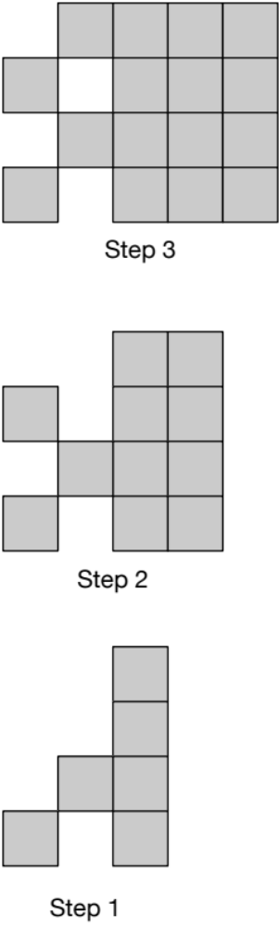
Pattern Talk: Tile Pattern
Consider the tile arrangement for Step 3 at right.
- Count the number of tiles in the arrangement.
- How did you count the tiles?
- Find a way to count the tiles so that so that the
relationship between the number of tiles and
the Step Number is evident.
- Share your ways of counting the tiles with your
group when asked to do so.

Study the tile arrangements for Steps 2 and 1.
- Does one of the ways you counted the tiles for
Step 3 also work to count the tiles for both
Step 2 and Step 1?
- Is the relationship between the number of tiles
and the Step Number still evident for Step 2
and Step 1? Explain your counting process and
the relationship between the number of tiles
and the step number.

In this lesson, you will explore several tile patterns. Each pattern grows in a predictable way. It is your job to determine how each pattern is growing. Some of the patterns are linear or proportional linear. Other patterns are not linear. Can you distinguish which patterns are linear or proportional linear from those that are not? Use what you’ve learned about linear relationships to help you!

Activity: Analyzing Tile Patterns
Use tiles to model each pattern. Use color to show how each pattern grows. For example, choose a color for tiles that are new in Step 2 when compared to Step 1. Use the Step 2 color to show where these same tiles appear in all subsequent steps. Find a way to count each pattern of tiles so that the relationship between the number of tiles and the step number is evident.
Work on Pattern A. When you’re done, share the different ways you colored the pattern with your group and when asked to do so, with the class. Use that information to draw Steps 0 and 4 and to find the equation.
Continue working on patterns B through F.
When the class has finished work on Analyzing Tile Patterns, as a group, claim one pattern. You will share your coloring of the pattern and equation with the class.
Once all patterns are posted, study each group’s work. Determine if you agree or disagree and why. When reporting, group members who did not put the pattern on the board will explain the work presented.

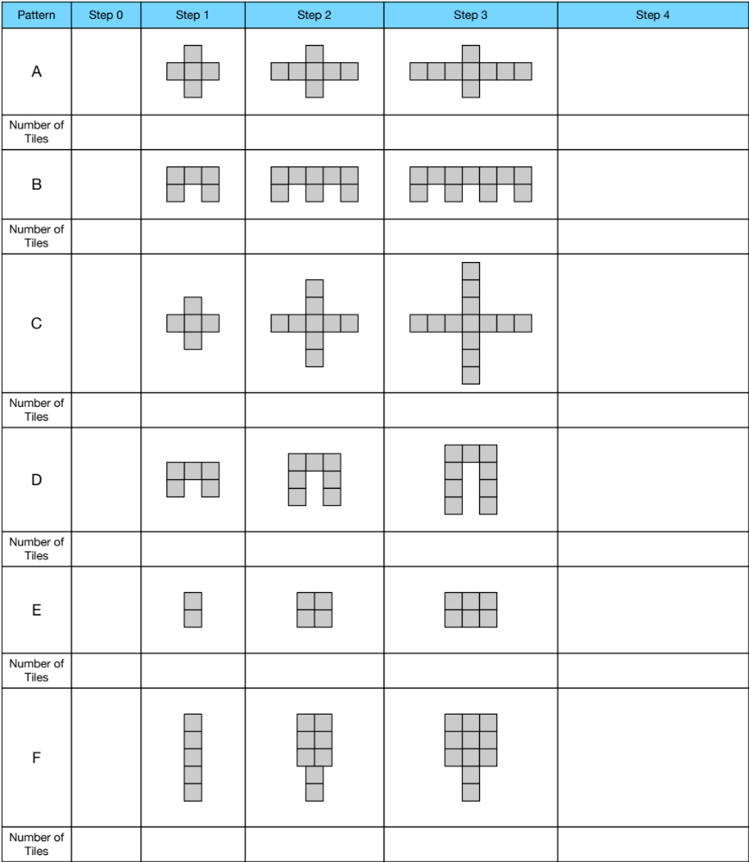
Analyzing Tile Patterns
Study the visual patterns. Assume each pattern continues infinitely and grows predictably. Determine the following for each pattern:
1. How is the pattern growing? Use colors or numbers to show how tiles are added to the pattern from one step to the next. Show how the pattern builds from one step to the next.
2. Draw Step 4. Draw Step 0.
3. For each step, determine the number of tiles needed.
4. Determine if the pattern is proportional linear, linear, or other. Explain your decision.
5. For each linear and proportional linear pattern, find an equation that gives the number of tiles in a step based on its step number.
6. For linear and proportional linear patterns, determine what part of the pattern relates to the slope. Determine what part of the pattern relates to the y-intercept. Explain both.

2.9 Homework
1. Some students say that you can find the slope from a table by dividing the value of y by the value of x for a single data point.
a. Does this method ever work? If so, for what types of functions will this method work? Give at least one example. Why does the method work?
b. Try this method for finding slope on the function below. Does the method work? Why or why not? Is the data below linear? How do you know?
x | 4 | 6 | 8 | 10 | 12 | 14 | 26
y | 7 | 11 | 15 | 19 | 23 | 27 | 51
c. For which types of functions will this method for finding slope fail? Why does it fail?
2. Analyze the tile pattern shown below. Draw the figure for Step 0 and for Step 5.
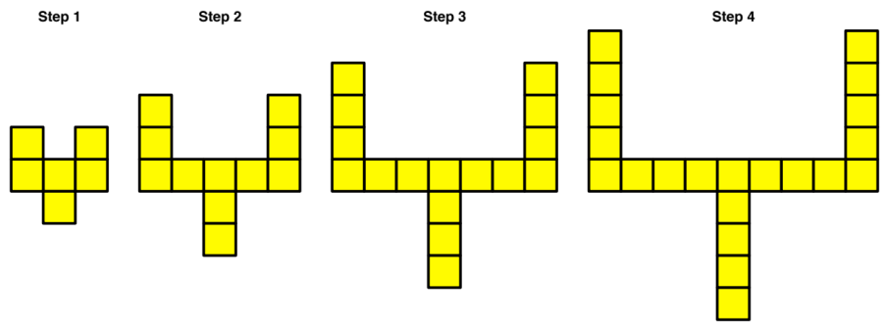
Step 0 Step 5

a. Describe the pattern you used to draw Step 5. How do you know you are correct?
b. What equation models the relationship between the step number and the number of tiles needed. How do you know?
c. As the pattern grows, what physical features of the design are represented by the slope? How do you know?
d. What part of the design is responsible for the y-intercept? How do you know?
e. Suppose the tile pattern did not have the tiles creating the stem at the bottom of each figure above. How would the equation change? Explain your thinking.
f. Would the graph of the design in problem 2e have the same y-intercept, smaller
y-intercept, or larger y-intercept than the graph of the design in problem 2a? How do you know?
g. Find an equation to fit this new design. Explain your work.
3. Complete the student page, Analyzing More Tile Patterns. Follow the directions on the student page. Be prepared to share your work with your group and class.
Analyzing More Tile Patterns
Study the visual patterns. Assume each pattern continues infinitely and grows predictably. Determine the following for each pattern:
1. How is the pattern growing? Use colors or numbers to show how tiles are added to the pattern from one step to the next. Show how the pattern builds from one step to the next.
2. Draw Step 5. Draw Step 0.
3. For each step, determine the number of tiles needed.
4. Determine if the pattern is proportional linear, linear, or other. Explain your decision.
5. For each linear and proportional linear pattern,
a. Find an equation that gives the number of tiles in a step based on its step number.
b. Determine what part of the pattern relates to the slope. Explain your choice.
c. Determine what part of the pattern relates to the y-intercept. Explain your choice.

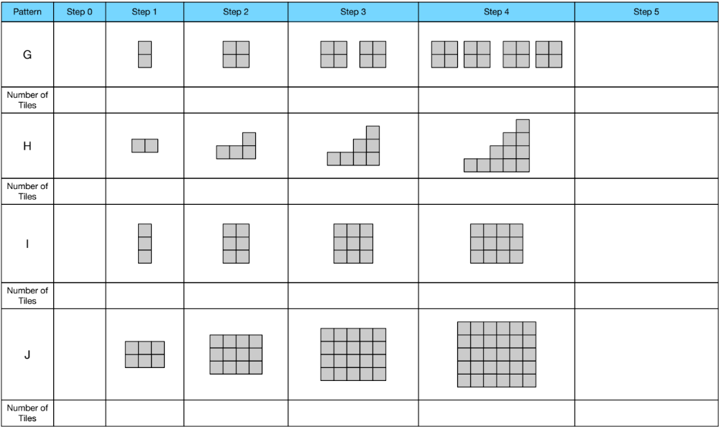

4. For the non-linear patterns in the student page, Analyzing More Tile Patterns,
a. Explain how you know the pattern is not linear. Use more than one representation to justify your choices.
b. Use a table to show how the number of tiles is growing. Remember not to simplify the table values too soon. Describe how each pattern is growing in words.
x | y
0
1
2 | 4 = 2 • 2 = 2²
3 | 8 = 2 • 2 • 2 = 2³
4
5
For example, consider Pattern G. Create a table like the one at right. Notice that each quantity shows how it arises from the one before it. How does the number of tiles in step 4 relate to the number of tiles in step 3? How does the step number relate to the number of tiles for that step? Back up the table from step 2 to step 1 then to step 0.
c. Stretch your equation-finding abilities to find equations for some of the non-linear tile patterns. Your work with tables can help. Explain how you know your equations are correct.
d. You have seen a pattern similar to Pattern H twice before. Do you recall where? How is Pattern H related to the patterns you saw previously? How might you find an equation to model this pattern?
5. Consider both student pages, Analyzing Tile Patterns and Analyzing More Tile Patterns. Choose 3 tile patterns from each page. For each tile pattern:
a. Determine how many tiles you need to make Step 100. Explain how you know.
b. A bag contains 60 tiles. What is the largest Step number you can build with 60 tiles? (You are only building the design for this single step, not any of the previous steps.) Explain your choice.

